

DESIGN DOCUMENT

Team 6

December 12, 2017

Revision D

Revision Log

|  |  |  |
| --- | --- | --- |
| Revision | Description | Date |
| A/B | Conceptual and Preliminary Design Review | 10/17/2017 |
| C | Critical Design Review | 11/09/2017 |
| D | Analysis and Final Report | First Draft 12/09/17  Final Draft 12/16/17 |

Table of Contents

1.0 Overview and Mission Statement .............................................................................................4

1.1 Mission Statement..........................................................................................................4

1.2 Mission Overview..........................................................................................................4

1.3 Hypothesis.....................................................................................................................5

2.0 Requirements Flow Down.........................................................................................................6

2.1 Level 0 Requirements....................................................................................................6

2.2 Level 1 Requirements…………………………………………………………………6

3.0 Design........................................................................................................................................7

3.1 Final Parts List………………………………………………………………………....7

3.2 Design Overview……….........................................................................................................10

3.3 Structure ......................................................................................................................10

3.4 Subsystem Design........................................................................................................12

3.4.1 Scientific Sensor Design……………………...............................................12

3.4.2 Experimental Design…………………….....................................................12

3.4.3 Command and Data Handling System Design..............................................14

3.4.4 Power System Design...................................................................................15

3.4.5 Electrical System Design..............................................................................15

3.4.6 Imaging System Design................................................................................15

3.4.7 Thermal System Design................................................................................15

3.5 Data Retrieval and Analysis.........................................................................................15

3.6 Concept of Operations.................................................................................................17

3.7 Functional Block Diagrams.........................................................................................18

4.0 Management ............................................................................................................................19

4.1 Organization Chart.......................................................................................................19

4.2 Schedule.......................................................................................................................20

5.0 Budget and Weight..................................................................................................................21

6.0 Testing and Safety....................................................................................................................23

6.1 Test Plan ......................................................................................................................23

6.2 Safety...........................................................................................................................26

6.3 Test Results………..………………..………………………………………………..27

6.3.1 Drop Test……….………………………………………………………….27

6.3.2 Whip Test…………………………………………………………………..27

6.3.3 Stair Test…………………………………………………………………...27

6.3.4 Cold Test…………………………………………………………………...27

6.3.5 Camera Test………………………………………………………………..29

6.4 Mission Simulation…………………………………………………………………..29

7. Expected Results........................................................................................................................31

7.1 Sky Screw....................................................................................................................31

7.2 TLCMEG.....................................................................................................................31

7.3 Temperature Sensor.....................................................................................................32

7.4 Pressure Sensor............................................................................................................32

7.5 Humidity Sensor..........................................................................................................33

7.6 Accelerometer..............................................................................................................33

8. Launch and Recovery…………………………………………………………………………34

8.1 Launch Plan………………………………………………………………………….34

8.2 Data Recovery……………………………………………………………………….34

8.3 Condition of Payload at Landing Site..……………………………………………...34

9.0 Results, Data Analysis, Failure Analysis, and Conclusions………………………………....35

9.1 Sensor Data Results…………………………………………………………………35

9.1.1 Temperature Sensor Data….……….……………………………………….35

9.1.2 Humidity Sensor Data………………………………………………………35

9.1.3 Pressure Sensor Data………..………………………………………………36

9.1.4 Accelerometer Sensor Data…………………………………………………36

9.2 SkyScrew………....…………………………………………………………………37

9.2.1 SkyScrew Results………..…………………………………………………37

9.2.2 SkyScrew Data Analysis...…………………………………………………37

9.2.3 SkyScrew Failure Analysis...……....………………………………………38

9.2.3.1 Electrical Investigation……………………………………………38

9.2.3.2 Structural Investigation……………………………………………39

9.2.4 SkyScrew Failure Replication...…....………………………………………40

9.3 TLCMEG………....…………………………………………………………………41

9.3.1 TLCMEG Results………..…………………………………………………41

9.3.2 TLCMEG Data Analysis...…………………………………………………42

9.3.3 TLCMEG Failure Analysis...………………………………………………43

9.3.2 TLCMEG Failure Replication...……………………………………………43

9.4 Conclusion…………………………………………………………………………...43

10.0 Ready for Flight.………....…………………………………………………………………44

11.0 Lessons Learned.………....…………………………………………………………………44

12.0 Message to Next Semester.…………………………………………………………………44

**1.0 Overview and Mission Statement**

1.1 Mission Statement

The mission of project SkyScrew is to launch a BalloonSat into the near-space environment of approximately 30 kilometers above the surface to establish the viability of generating renewable energy from the environment directly around the BalloonSat. By using the wind flow from the upward motion of the balloon to rotate a “SkyScrew” independent of the BalloonSat, electricity can be generated with a DC Motor. The lateral movement of the BalloonSat will cause a magnet within a solenoid to move back and forth, further generating electricity. Lastly, all requirements will be met as stated in the ASEN 1400 Course.[1]

1.2 Mission Overview

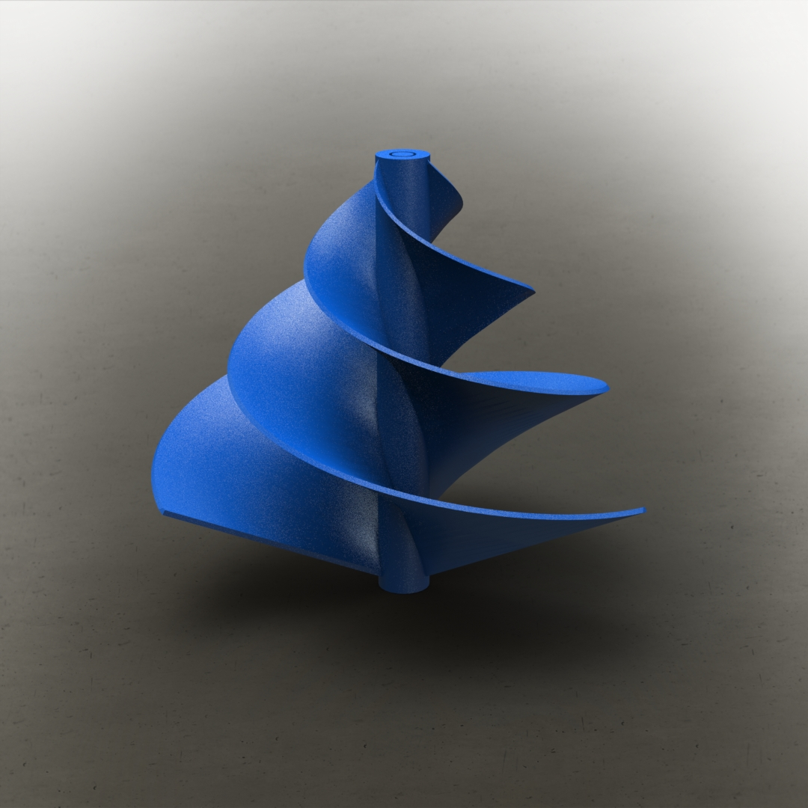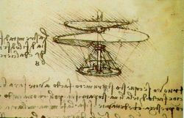The goal of team ScrewUp is rooted in a passion to create renewable energy through innovative means. The University of Colorado Boulder has been a leading force in the march toward a responsible green future and this project follows in the footsteps of these ideals.[2] Project SkyScrew is a high altitude BalloonSat designed to take advantage of the motion from the chaotic ascent and descent of the satellite to generate power. In order to do this, Project SkyScrew will have two systems within the BalloonSat to generate power. The first system will be an external design element that will harness the wind from the ascent to spin a screw-like attachment at the top of the BalloonSat. The inspiration of this screw is drawn from the Da Vinci Aerial Screw which is an apparatus that when rotated on an axis would ascend vertically through the air (*Figure 1*).[3] This idea will be modified to work as a vertical wind turbine (*Figure 2*). A 3D printed screw will be attached to the top side of the box, it’s rotation is kept independent from the rotation of the box. Within the box, the rotation of the screw will be attached to a DC motor. As the BalloonSat ascends, the airflow will cause the screw to spin thus generating energy through the DC motor. This use of wind energy is ultimately advantageous as wind turbines are one of the lowest-priced energy sources in the country.[4] The idea of using upper atmosphere wind is being utilized in the design of high 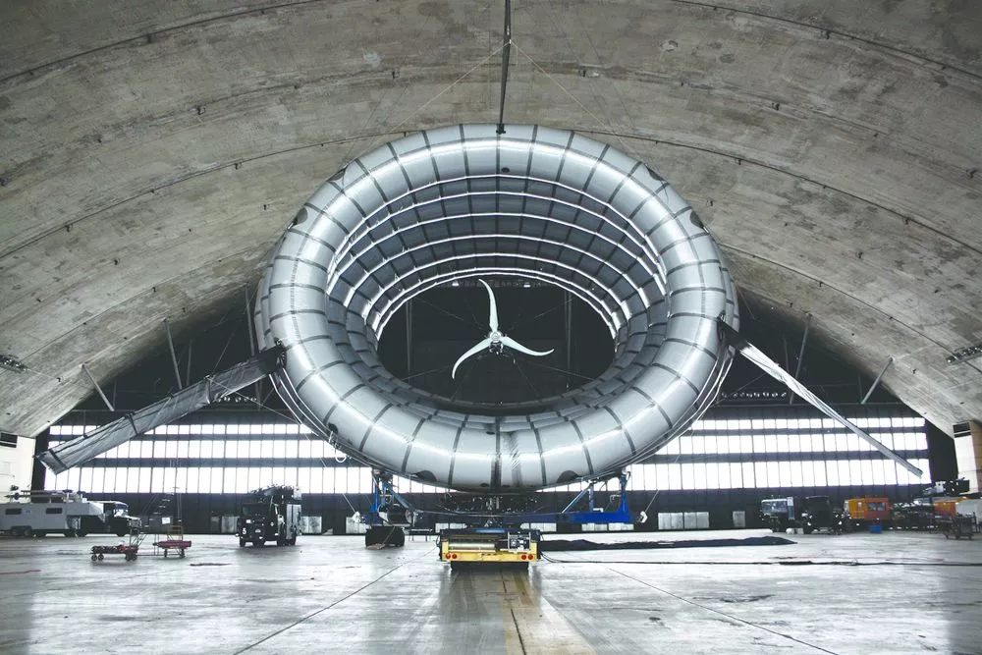altitude air turbines (*Figure 3)*. The blades are contained in inflatable casings to elevate them and inflatable fins combat wind directional changes. The turbines are anchored to the ground by cables which also move the power generated. This system was designed to set up wind energy in locations with low access or short periods of use. This concept is most comparable to the SkyScrew upper atmosphere electric generation system.

*Figure 2 - SkyScrew*

*Figure 1 - Da Vinci Aerial Screw*

*Figure 3 - Buoyant Air Turbine*

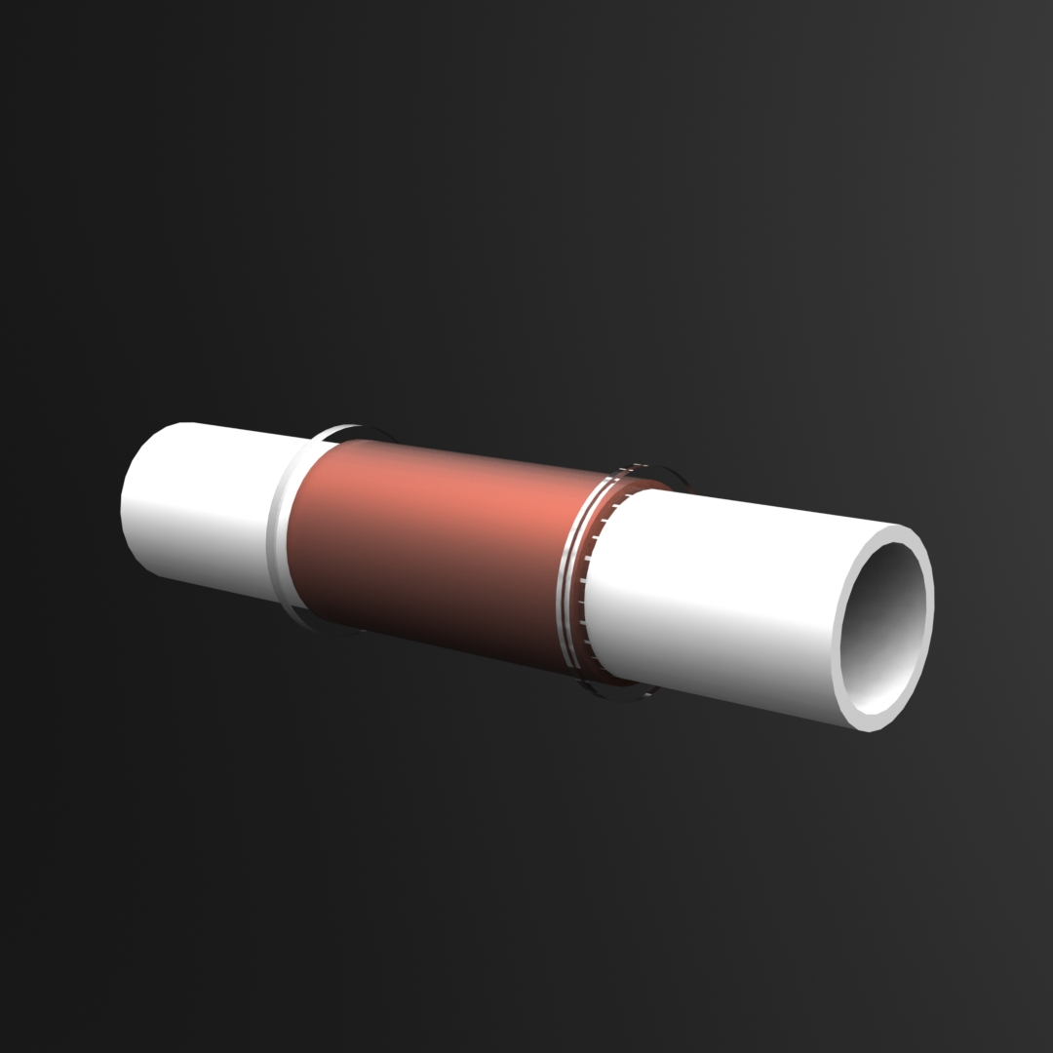The second system will be an internal design element that will take advantage of the lateral motion of the BalloonSat. The motion of the BalloonSat from being whipped around during ascent and especially during the descent will be converted to usable energy through a tubular design. The motion of the box will prompt the a magnet within a tube with copper magnet wire coiled to move back and forth. The motion of the magnet will induce an electromotive force (EMF) which generates voltage. This design is called the Tubular Lateral Chaotic Motion Electric Generator (TLCMEG) (*Figure 4*). The same type of solenoid and magnet designs are used in industrial power generation plants. For example, steam is fed through a chamber containing propellers to spin a shaft, thereby rotating the magnet within the solenoid. The same principle works in some DC Motors, for example the one used in this BalloonSat. The overall design of the BalloonSat can be used on a larger scale in order to replace short-term power sources in larger BalloonSats. While the energy generation mechanisms take up the majority of the mass allowed in the BalloonSat, Project SkyScrew hopes to prove that on a larger scale the whole system would weigh less than the amount of batteries needed for the same amount of power.

*Figure 4 - TLCMEG*

1.3 Hypothesis  
 Team ScrewUp aims to prove that generating power from the surroundings is a viable option on a larger scale. By harnessing the power from the vertical airflow and the horizontal swing on the descent, the BalloonSat will be able to generate and measure power generated post-launch, thus proving the efficiency of utilizing renewable energy. Team ScrewUp shall consider this mission a success if the total amount of power generated is at least 500 watt-hours.

**2.0 Requirements Flow Down**

The top-level requirements for project Skyscrew consist of three main components. The first is to generate power from the SkyScrew. This is achieved by the rotation of the screw which is connected to an inner drive shaft that has a gear attached to it. The drive shaft gear then spins the gear attached to the DC motor and generates power. The second part is generating power from the TLCMEG through lateral motion of the box. The horizontal motion of the box causes the neodymium magnet to move within the tube. As it moves, the change in magnetic flux causes an EMF to be produced within the coil.

2.1 Level 0 Requirements

|  |  |  |
| --- | --- | --- |
| Number | Requirement | Origin |
| 0.1 | The Project Skyscrew BalloonSat shall be sent to approximately an altitude of 30 km. | Mission Statement |
| 0.2 | The Project Skyscrew BalloonSat (Arduinos) shall collect environmental data throughout the entire flight. | Mission Statement |
| 0.3 | The Project Skyscrew BalloonSat shall generate electricity through the movement of the system. | Mission Statement |
| 0.4 | The Project Skyscrew BalloonSat (Arduinos) shall collect voltage and current measurements of the Skyscrew and TLCMEG. | Mission Statement |
| 0.5 | The Project Skyscrew BalloonSat and all the data collected during flight, shall be successfully recovered after landing. | Mission Statement |
| 0.6 | Team ScrewUp shall meet all the requirements of the ASEN 1400 course in the Fall 2017 as outlined in the Request for Proposal. | Mission Statement |

2.2 Level 1 Requirements

|  |  |  |
| --- | --- | --- |
| 1.1 | The Project Skyscrew BalloonSat shall have a pre-approved metal flight string interface tube that runs through the center of the BalloonSat and it will have no sharp edges. | RFP |
| 1.2 | The Project Skyscrew BalloonSat flight string interface tube shall allow for the flight string to run through the tube and shall be secured in such a way so the string shall not pull through the box. | RFP |
| 1.3 | The Project Skyscrew BalloonSat shall have all heater and Arduino switches and LEDs labeled and identified on the exterior of the box. | RFP |
| 1.4 | The Project Skyscrew BalloonSat’s internal temperature shall remain above -10˚C during the flight. | RFP |
| 1.5 | The Project Skyscrew BalloonSat’s total weight shall not exceed 1000 grams (approved for extra weight). | RFP |
| 1.6 | The Project Skyscrew BalloonSat shall be powered by 7 9V batteries that will be used to power two arduinos, one heater, and an operational amplifier chip for the TLCMEG. | RFP |
| 1.7 | The Project Skyscrew BalloonSat shall be structurally tested prior to launch by a whip, drop, stair, and cold test. | RFP |
| 1.8 | The Project Skyscrew BalloonSat GoPro shall be tested prior to flight to test the functionality of the software. | RFP |
| 1.9 | The Project Skyscrew BalloonSat shall have DC motor that generates power via the SkyScrew which is connected to a circuit that shall be connected to an Arduino Uno to record power generation. | RFP |
| 1.10 | The Project Skyscrew BalloonSat’s TLCMEG component shall be connected to a circuit that shall be connected to an Arduino Uno to record power generation. | RFP |
| 1.11 | The Project Skyscrew BalloonSat shall perform calibration tests to verify correct readings of the power generated by the TLCMEG and SkyScrew via multimeter and oscilloscope. | RFP |

**3.0 Design**

3.1 Final Parts List

|  |  |  |
| --- | --- | --- |
| **Subsystem** | **Part** | **Part Number (if purchased)** |
| Arduino 1 (sensors) | Arduino |  |
|  | Arduino switch |  |
|  | Balloon shield |  |
|  | Internal temperature sensor |  |
|  | External temperature sensor |  |
|  | Humidity sensor |  |
|  | Pressure sensor |  |
|  | Accelerometer sensor |  |
|  | Openlog |  |
|  | Micro SD card |  |
|  | 9V battery |  |
| Arduino 2 (mission) | Openlog attachment |  |
|  | Micro SD card |  |
|  | 9V battery* |  |
| Heating | Heater |  |
|  | Heater switch |  |
|  | 3 9v batteries |  |
| Media | GoPro |  |
|  | Micro SD card |  |
| SkyScrew | 48 g PLA |  |
|  | 2 8 mm internal diameter bearings | 0733180833341 |
|  | 2 PLA bearing housings |  |
|  | 14 cm brass tube* | 1412119971 |
|  | 20 cm aluminum shaft* | 815000068-0 |
|  | 3V DC motor* | B01I6MDXV6 |
|  | 1 ohm resistor |  |
|  | 7 conducting wires |  |
| TLCMEG | 16 cm, 2.4cm outer diameter PVC tube* |  |
|  | 2 acrylic endstops |  |
|  | 270 ohm resistor |  |
|  | 100 ohm resistor |  |
|  | 1000 ohm resistor |  |
|  | 120000 ohm resistor |  |
|  | Operational amplifier |  |
|  | ½” Dia.x1” long rod neodymium magnet | From United Nuclear |
|  | 100 µF capacitors |  |
|  | 53 conducting wires |  |



*Side view of BalloonSat (cm)*

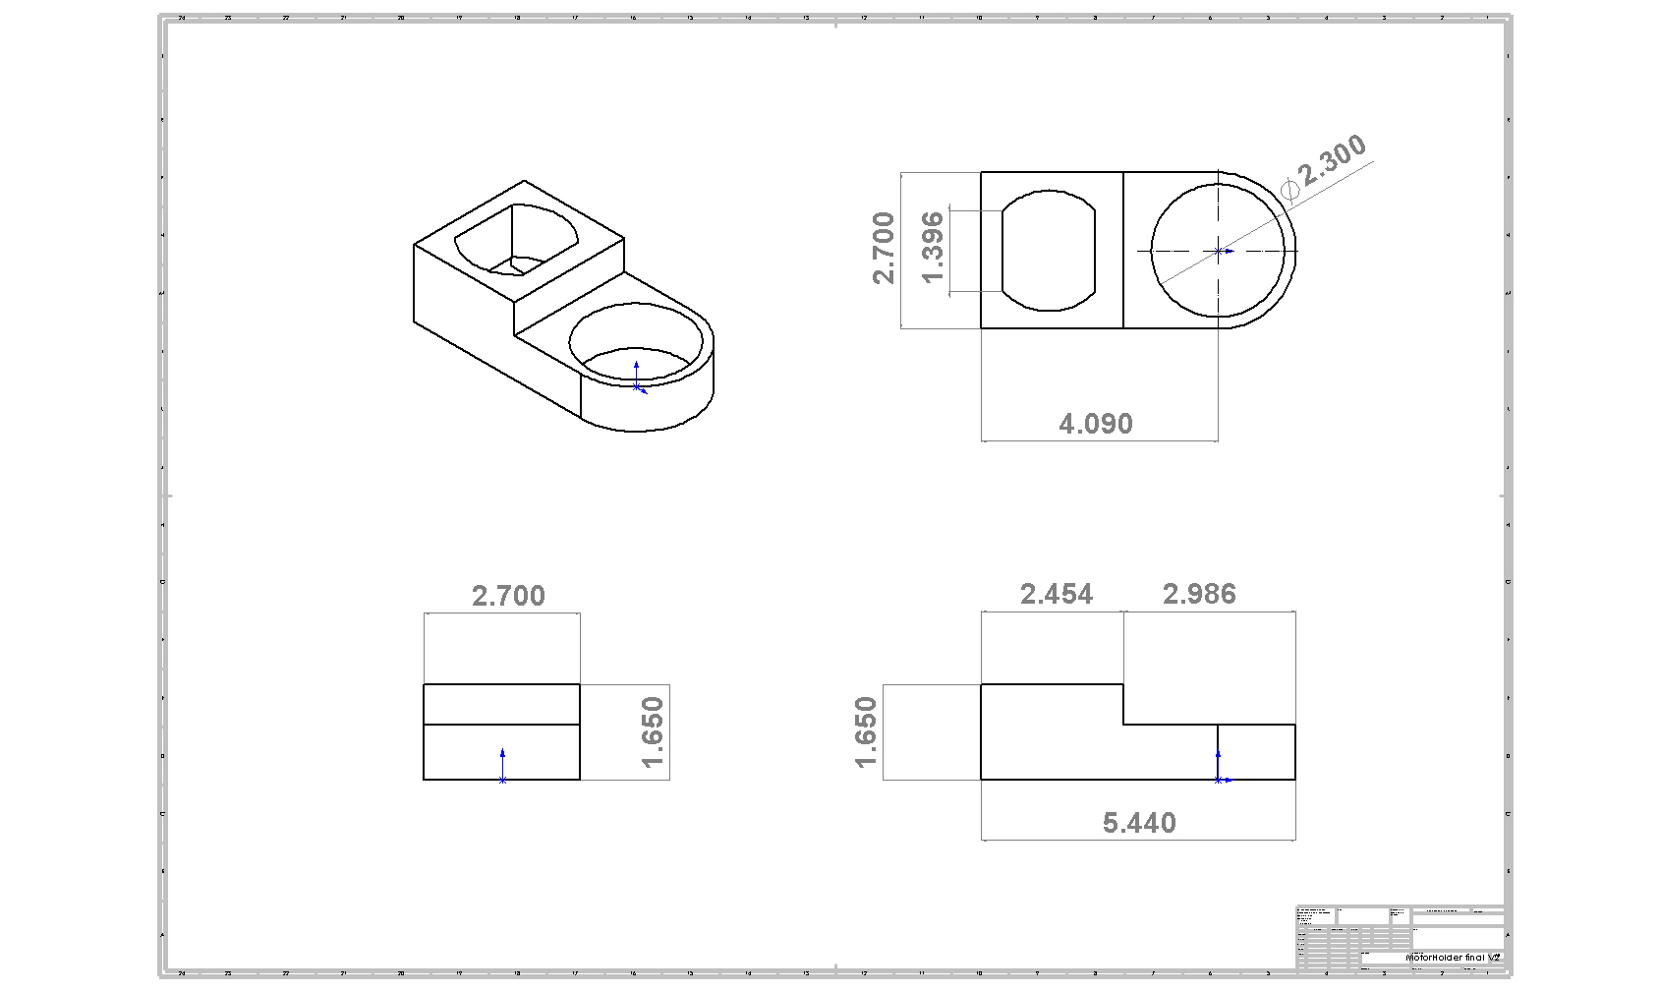

*Motor Holder Specifics*

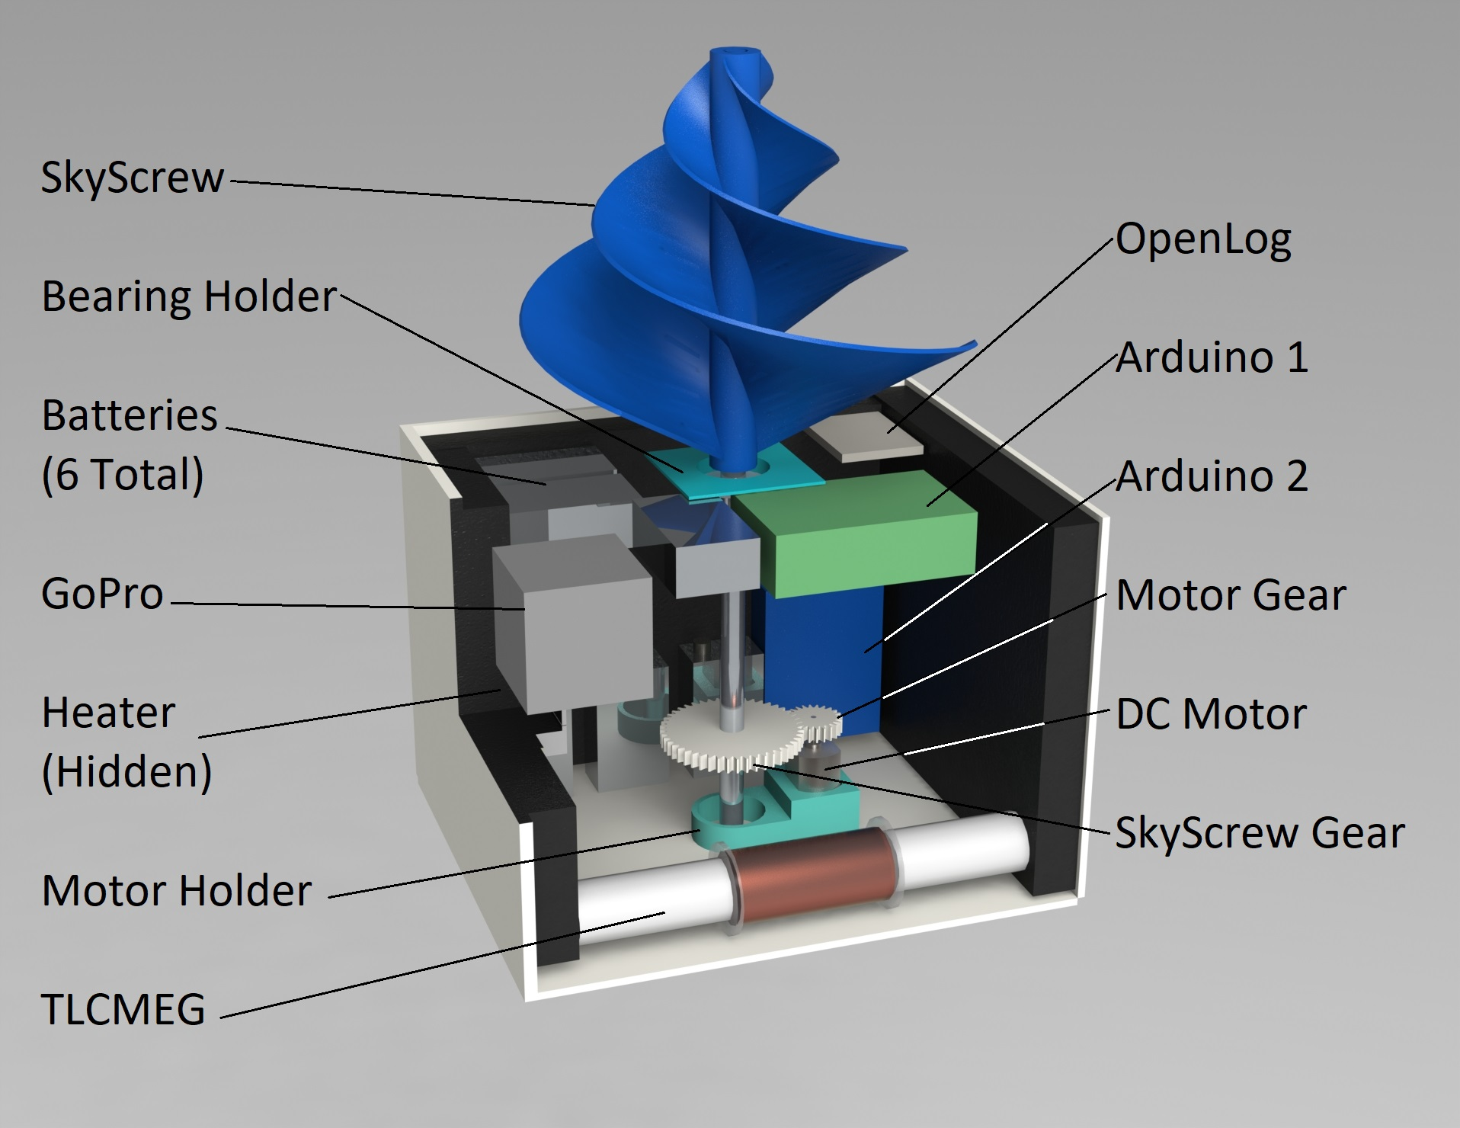

*Figure 6 - 3D rendering of BalloonSat*

3.2 Design Overview

Team ScrewUp will construct a containment vessel for the experiments that provides a safe, stable environment to nestle fragile components and house data. The vessel will allow for separate rotational motion for the SkyScrew from the protected vessel. The vessel will, at all times during flight, protect against the harsh conditions encountered.

3.3 Structure

The SkyScrew team will construct their box with energy generation in mind. The box’s dimensions shall be 18.25cm x 15.25cm x 13cm. The box will have one large compartment, allowing internal dimensions of 16.25cm x 13.25cm x 11cm. The rectangular nature of the structure will allow increased swinging ability to generate more electricity with the TLCMEG. The decreased height of the BalloonSat will allow for more stability in the rotation of the SkyScrew. Foam core shall be utilized in construction for its high strength, lightweight, and insulation properties. Holes will be created to insert electrical control switches. The center of the bottom and top panels will feature holes for a pipe fixed to bearings to sit. An American flag will prominently be displayed on the exterior of the box. The contact details of Team ScrewUp will be put onto the box in order to increase the probability of recovery post-launch. Lastly, all documentation will be done in metric units in order to be consistent across the board.

The exterior of the box will have three LEDs protruding through the wall in order to indicate that both Arduinos and the heater are powered. Additionally, three switches will be accessible through the wall of the box in order to provide power to both Arduinos and heater before launch. A 3.6cm by 3.6cm hole will be cut out on one of the walls in order to provide a viewing hole for the GoPro Hero4. A bearing will be placed in the top and bottom wall to serve as a point where the Screw can rotate independently of the box. An aluminum tube will be attached to the inside ring of the bearings. The tube will protrude through the top side of the box and attach to the Screw. As the Screw rotates, the tube and screw rotate together but independently of the box due to the bearings. The tube has a smaller bearing attached to the top of the box whose diameter is smaller than that of the tube. This allows the string to spin separately from the screw, reducing friction. A small bearing is placed on the bottom of the box for the flight securement knot to nestle against. The string is then threaded through the bearings and the tube in preparation for flight.

The interior will consist of one large compartment which will house all the components. The inside will be lined by foam insulation, limiting the inside workspace to 17.25cm x 14.25cm x 12cm. The TLCMEG will be fixed to one side wall and the ends fixed to two walls. The two Arduinos will be placed against adjacent side walls. Arduino Two will be placed closest to the TLCMEG in order to reduce wiring difficulty. The heater will be situated adjacent to Arduino One against the side wall. The heater will then be able to provide heat effectively to all the components, while the internal temperature sensor measures internal temperature throughout the flight. Additionally, the compartment will house the six 9V Lithium Ion batteries as well

as the acceleration, humidity, pressure and GoPro sensors which will collect data. Lastly, two 4GB and one 32GB microSD cards will be in this compartment, onto which all the data will be stored.

The TLCMEG will be made from a 16 cm long PVC tube. Externally, there will be two acrylic discs attached to the tube, centered in the middle. The magnet wire will be wrapped around the PVC tube and the acrylic discs keep it centered in the middle of the tube. The magnet wire is centered in the middle of the tube because through testing Team ScrewUp found that it is less efficient to wrap the same amount of magnet wire across the whole tube. The magnet will be placed within the tube and be allowed to move freely. This magnet is 1.27cm x 2.54cm and has a pulling force of 16 pounds. The ends of the tube will be closed with a piece of insulation, attached to an acrylic disc to fit over the ends. The TLCMEG will be mounted to three side walls and the bottom with hot glue and will be supported by acrylic discs. This gives the TLCMEG six separate attachment points to four surfaces of the box. It is imperative that the TLCMEG is attached securely, as the momentum of the sliding magnet will cause significant strain on the mounting points. The TLCMEG is designed to harness the lateral motion of the box during flight and specifically after burst.

3.4 Subsystem Design

*3.4.1 Scientific Instruments*

**Accelerometer**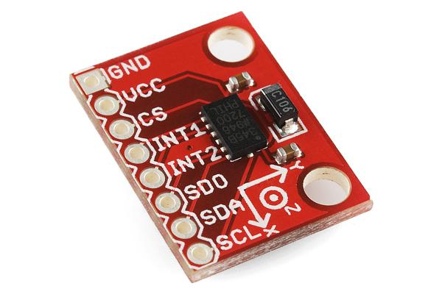

The accelerometer provided by the Colorado Space Grant Consortium (COSGC) will record the acceleration of the BalloonSat in terms of horizontal and vertical motion rates. It will be attached to Arduino One. The data will be fed to Arduino One, which in turn will store the data on the 4GB Micro SD Card.

**Temperature Sensors**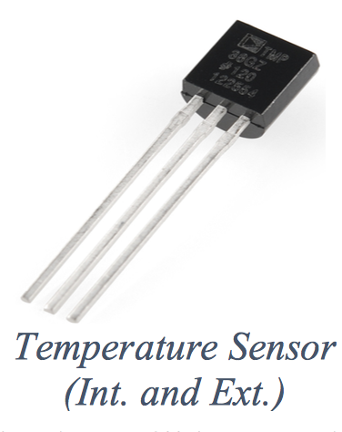

Project SkyScrew will feature two temperature sensors provided by the COSGC. Both temperature sensors will be connected to Arduino One. The first of the temperature sensors will be soldered closely to the Balloon Shield. It will measure temperatures on the inside of the satellite. The second temperature sensor will have long wires connecting it to the Balloon Shield and will stick out of the walls of the satellite. It will take external temperature measurements.

**Humidity Sensor**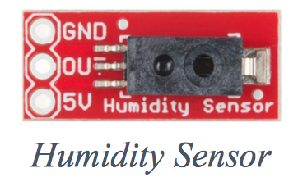

The Humidity Sensor will be connected to Arduino One. It will measure humidity levels on the inside of the satellite throughout flight. The Humidity Sensor will be provided to Project SkyScrew by the COSGC.

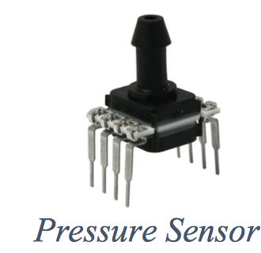

**Pressure Sensor**

The pressure sensor provided by the COSGC will record the pressure of the surrounding air in respect to time. The sensor will be attached to Arduino One, which will store the data on a 4GB Micro SD Card.

*3.4.2 Experimental Design*

The main purpose of Project SkyScrew is to generate electricity through the use of two different electricity-producing components. The SkyScrew acts as a miniature wind turbine and spins as air flows through it. The screw is connected to a gear system that is connected to a motor. With a gear ratio of 1:3, the motor is able to produce much more electricity than if the screw was directly connected to the motor. The other electricity-producing component is the TLCMEG. The TLCMEG is made up of a coil that's wrapped around a tube, in which a magnet slides back and forth as the BalloonSat swings on the rope. As the magnet passes through the coil an EMF, electromotive force, is induced. With the combination of both the SkyScrew and the TLCMEG, sufficient power will be produced so that the overall design could be used to power a larger scale system.

* Firstly, the power generated by the SkyScrew will flow though a 1Ω resistor. This allows the calculations of Ohm's law $V=IR$ to simply be $V=I.$ This means that the Arduino will be reading the voltage value but this will also be the current value. This also allows the power equation $P=IV$ to be $P=V^{2}.$ During testing Team ScrewUp found that this circuit dramatically reduces the voltage the SkyScrew produces, with values that have always been less than 0.1 volts. Due to such low voltage Team ScrewUpwill not be using a voltage divider circuit which would have only been necessary if the voltage had gotten close to 5V
* Secondly, the voltage produced by the TLCMEG will be fed to a voltage divider circuit in order to prevent 5V being sent to Arduino 2. Additionally, a Zenar diode will be used to protect the Arduino. Ohm’s Law can again be used to calculate the current produced, as discussed for the SkyScrew. This system will not include a low pass filter due to the noise having much lower voltage values than what is produced by the TLCMEG. Therefore, the need of the low pass filter is not needed as it is not disrupting the crucial data. Additionally, an operational amplifier circuit is used to boost the current output from the TLCMEG to lessen the negative influence of the noise on the data collected. A 9V battery is needed to power the amplifier circuit for measurement purposes. The image below depicts the evolution of the TLCMEG design. The first design (left) was inefficient as the single-layer of copper wire did not generate negligible power. Consolidating the coils in the center of the tube generated more power, but was not optimal, averaging 3V per swing. The final design has many more wraps around the center, along with the circuitry depicted in the following image. This design generates approximately 9V per swing.

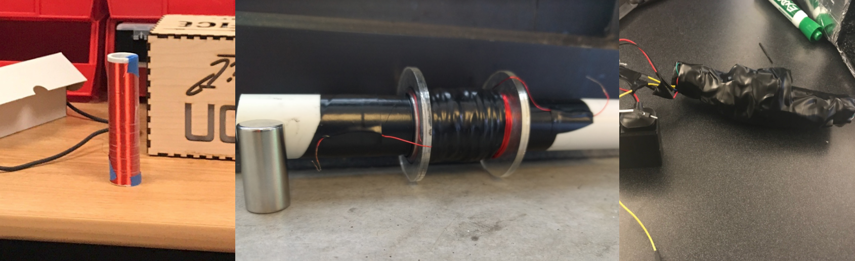

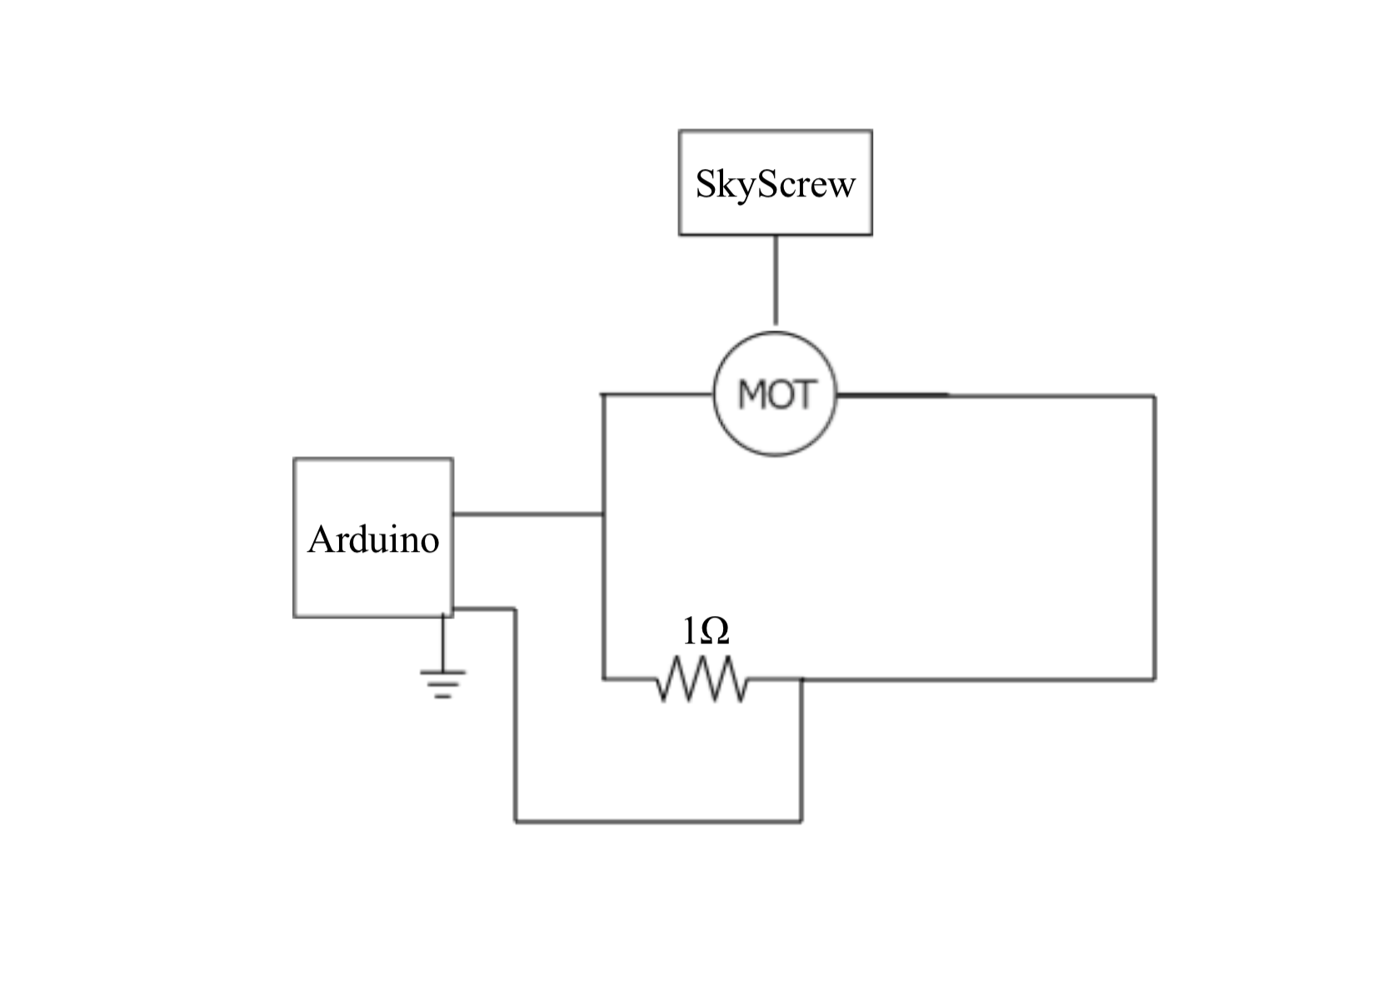

*1Ω Resistor Circuit*

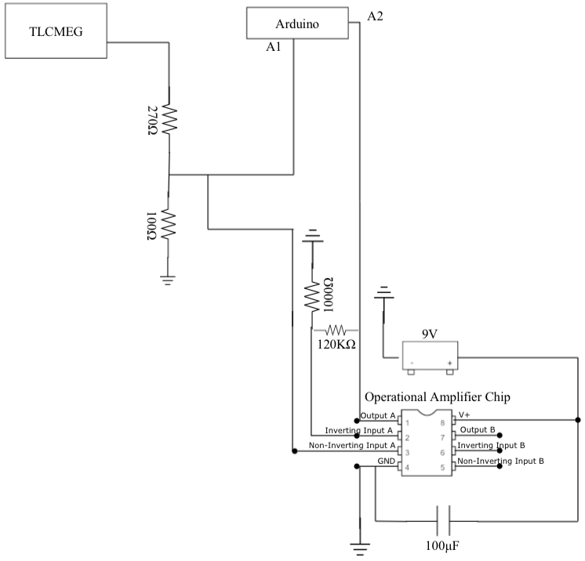

*TLCMEG Circuit*

*3.4.3 Command and Data Handling Design*

**Openlog**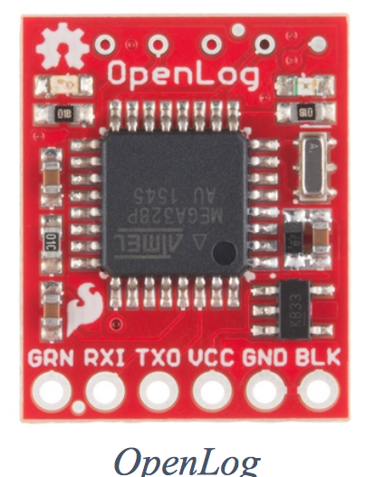

Each Arduino implemented by Project SkyScrew will write data to an SD through the OpenLog component. Each Arduino will be equipped with an OpenLog sensor and loaded with an SD card pre-launch. After the flight has concluded and the satellite string has landed, Team ScrewUp will retrieve the SD cards and the valuable data from the OpenLog. They will be taken back to CU where the data can be uploaded onto a computer and processed. Comparing temperature and pressure data to the voltage readings will provide a correlation between altitude and voltage generated by the SkyScrew.

*3.4.4 Power System Design*

Project SkyScrew has many components that needs to be powered throughout the entire flight. The power design will allow each system to have its own power source. Arduino One and Two will be attached to one 9V Lithium Ion battery each. The heater will be attached to three 9V Lithium Ion batteries. All three of these systems will have an integrated switch attached, which will be turned on right before launch. The GoPro Hero4 has a built in Lithium Ion battery and the camera will be switched on before launch.

*3.4.5 Electrical System Design*

Project SkyScrew has a total of three switches. Two of them are connected to each Arduino so that they can be switched on before launch. The other switch is integrated into the heater circuit in order to provide power to the heater element before launch. Each switch will have a related LED indicator to show that the Arduinos and heater are powered. The GoPro Hero4 has a built in button in order to power the camera. Since it is attached to a top corner of the box, there will be a hole, the same size as the power button, cut out of the foam core in order to turn on the camera with a wooden dowel stick. It also has an LED indicator to show that it is powered. All of the switches will be sufficiently protected by the foam core of the BalloonSat. This will be done in order to prevent damage to the component and prevent the system being switched off prematurely by a force on the BalloonSat.

*3.4.6 Imaging System Design*

The imaging system of Project SkyScrew will consist of a GoPro Hero4 Session camera. It will take 12 megapixel pictures throughout the entire flight and be stored onto a 32GB MicroSD Card. After flight, the images will be studied and then turned into a timelapse video.

*3.4.7 Thermal System Design*

The thermal system will consist of a heater powered by three 9V Lithium Ion batteries. This will prevent damage to all the components of Project SkyScrew as the temperatures will reach approximately -80 C. Additionally, the outside will be constructed out of foam core and the inside will have a lining of foam insulation in order to prevent heat loss during flight. The internal temperature will be kept above -10 C as required in the Request for Proposal of Fall 2017. Team ScrewUp will ensure that the requirement can be met by Project SkyScrew through a dry ice test.

3.5 Data Retrieval & Analysis

Data will be retrieved by removing the SD cards from the OpenLog modules in the Arduinos. Once Team ScrewUp has retrieved the SD cards Team ScrewUp will return to CU for data analysis. Using temperature, humidity, and pressure readings, the altitude will be determined. Using the altitude data in addition to voltage data, Team ScrewUp will form a relationship between power generated and the altitude. This information is directly relevant to the Aerial Screw component of the energy generation mission. The data most relevant to the TLCMEG is voltage readings when altitude is before, during, and after the burst event. The current and voltage data collected will inform Team ScrewUp of how realistic it would be to implement the design as a source of power for a balloon sat and conclusions will be drafted on mission success.

*Figure 4* and *Figure 5* below are an analysis of the possible condition that the BalloonSat may undergo while in flight. A 425 cm/s (~16km/h) airflow was moved from top to bottom over the BalloonSat. *Figure 4* denotes how pressure will build up, from the red areas to the blue areas there is a pressure difference of around 69 Pa. *Figure 5* denotes how the velocity changes as it flows across the BalloonSat with the orange outside area being 425 cm/s going all the way down to 30 cm/s in the dark blue areas. *Figure 7* shows what the BalloonSat may experience while in the jet stream. For this analysis a 4,917 cm/s (177km/h) wind was moved across the box, right to left, and the changes in velocity are displayed. Yellow is roughly 4,917 cm/s going all the way down to ~450 cm/s in the blue. These diagrams were helpful because of the projects reliance on wind speeds and an interaction with the environment, this gave Team ScrewUp detailed insight into exactly how the box may interact with the environment.

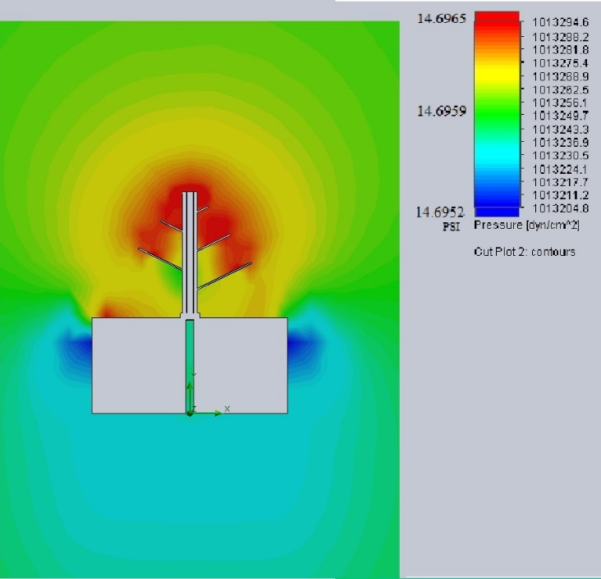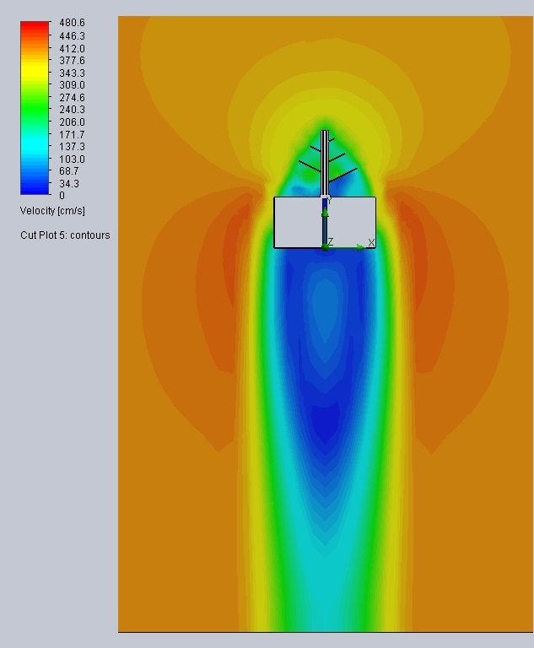*Figure 5 Pressure Cut plot Figure 6 Velocity Cut Plot*

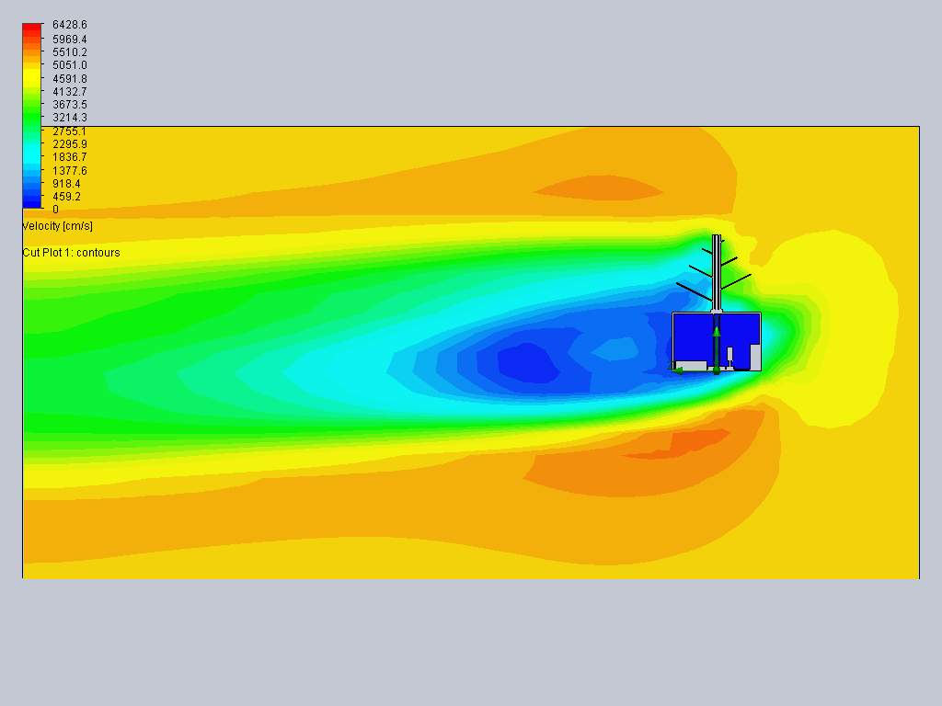

*Figure 7 Jet Stream analysis*

3.6 CONOPS

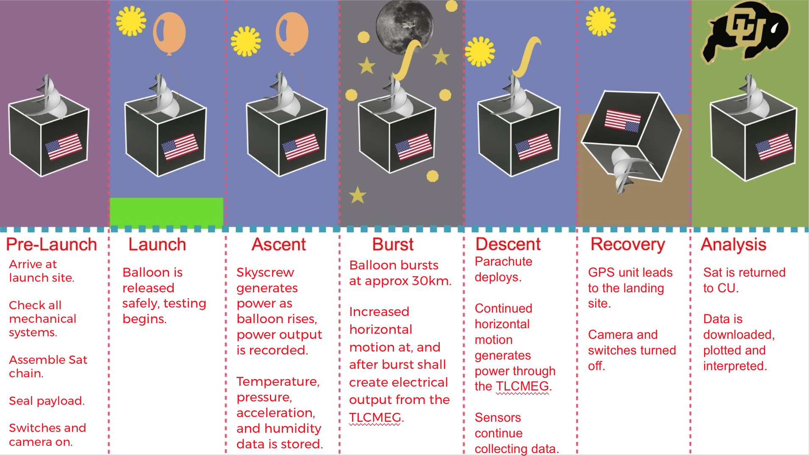

Upon arrival at the launch site, the BalloonSat is unloaded from the vehicle. The mechanical systems are checked for any malfunctions. Once the BalloonSat chain is assembled, the BalloonSat is sealed and all switches are placed in the “on” position. Upon release, the testing begins. As the payload ascends, all sensors collect data. The airflow over the BalloonSat causes the Sky Screw to rotate, generating energy. This energy output is recorded by Arduino 2. At approximately 30 kilometers above sea level, the balloon bursts, and the payload begins to fall. The burst of the balloon creates significant horizontal swing in the payload, which allows the TLCMEG to generate energy. The energy output is recorded by Arduino 2. As the payload descends, the parachute deploys and slows the chain. All sensors continue recording data throughout descent and landing. Once the payload lands, the GPS unit leads the team to the landing site. All switches are turned off and the BalloonSat is returned to CU where the data is downloaded and interpreted.

3.7 Functional Block Diagram

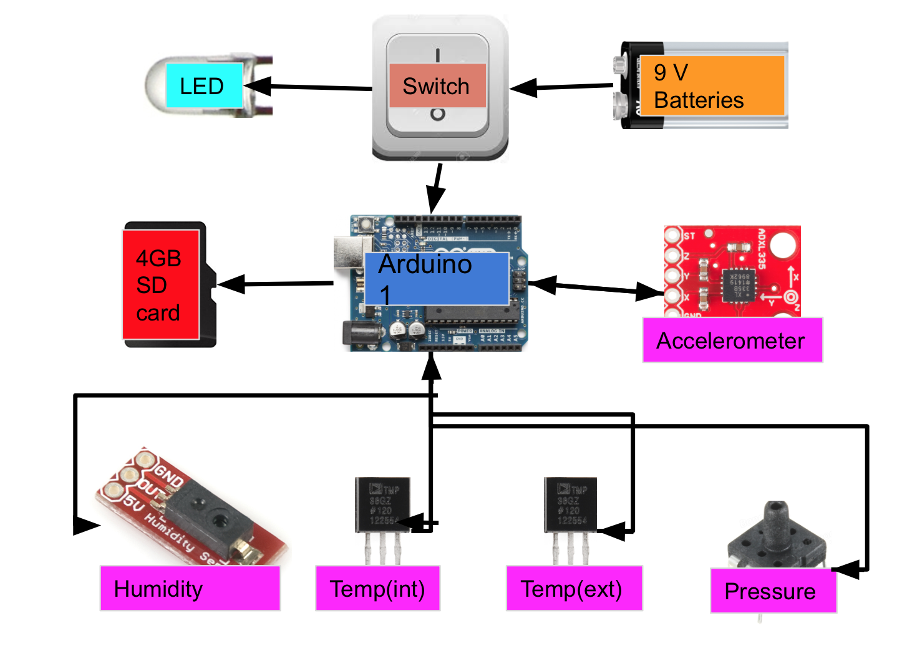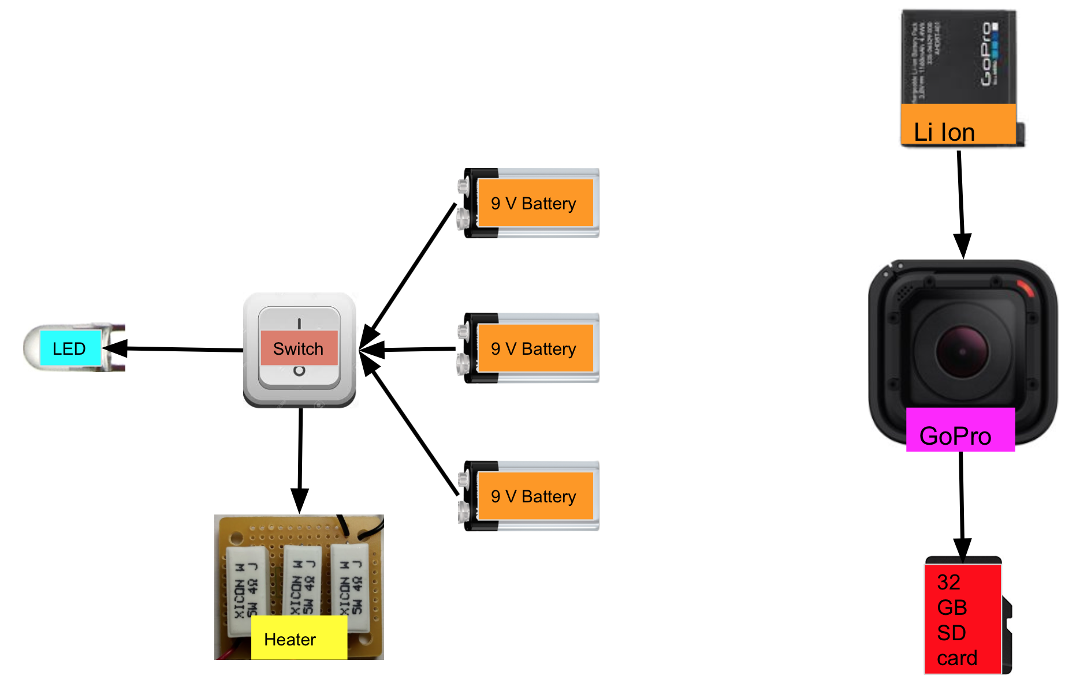The Functional Block Diagram depicts the interactions of every component in the BalloonSat. Team ScrewUp’s BalloonSat consists of four isolated systems. The systems are Arduino System One, Arduino System Two, Heater System, and Camera System. Both Arduino Systems will be powered by one 9V battery each, connected with a switch and an LED for external powering and indication. Arduino System One consists of Arduino One, a power system, a microSD card, and the required sensors. Each sensor sends data to Arduino One, which saves said data to the 4GB microSD card. Arduino System Two consists of Arduino Two, a power system, a microSD card, and the SkyScrew and TLCMEG. Using the same power and data recording systems as Arduino System One, Arduino Two will receive data in the form of voltage from the SkyScrew and TLCMEG. The voltage produced by the TLCMEG will be passed through a voltage divider and custom current circuit. The power produced by the SkyScrew will be fed through a 1 ohm resistor. The Heater System consists of three 9V batteries, a switch, an LED indicator, and three power resistors. When powered, the resistors provide heat for the inside of the BalloonSat. Finally, the Camera System consists of a camera, a battery, and a microSD card. The battery powers the camera, and recorded data is saved to the microSD card.

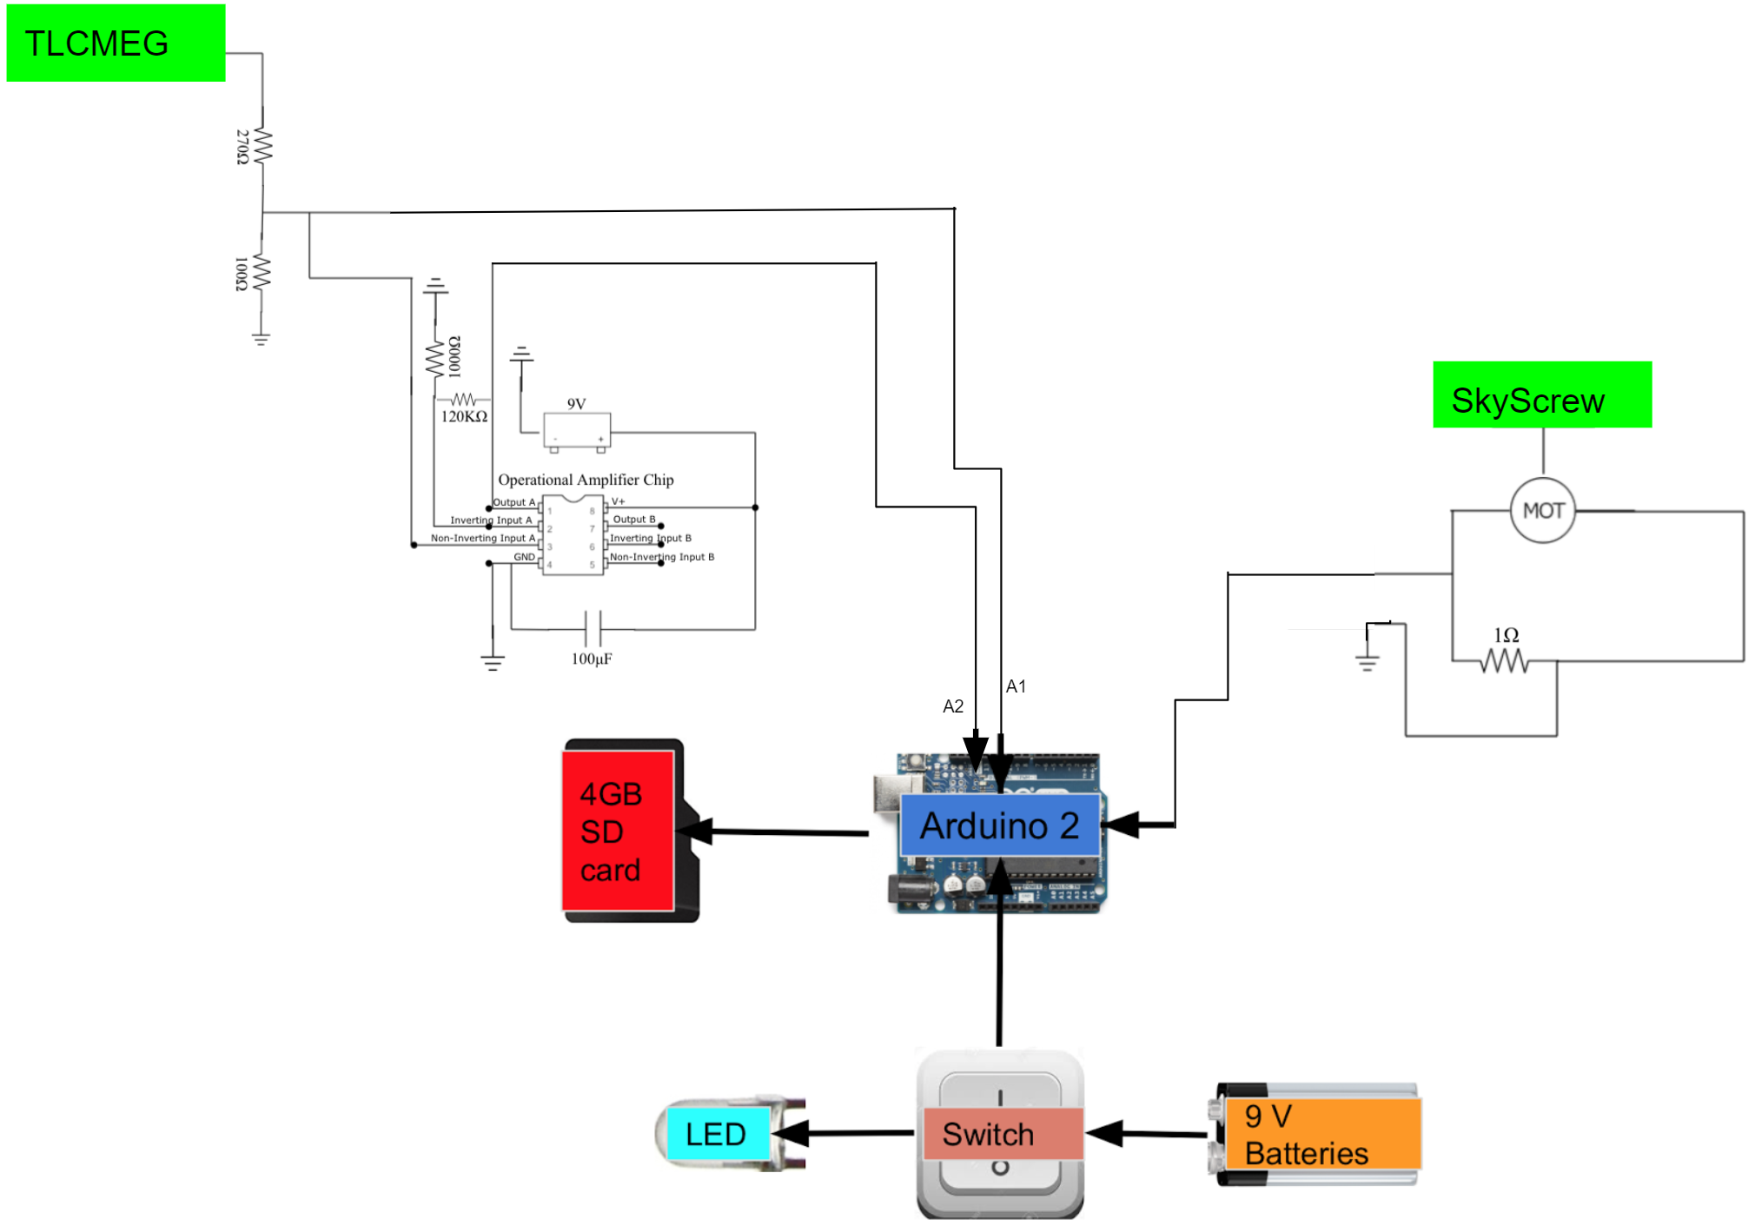**4.0 Management**

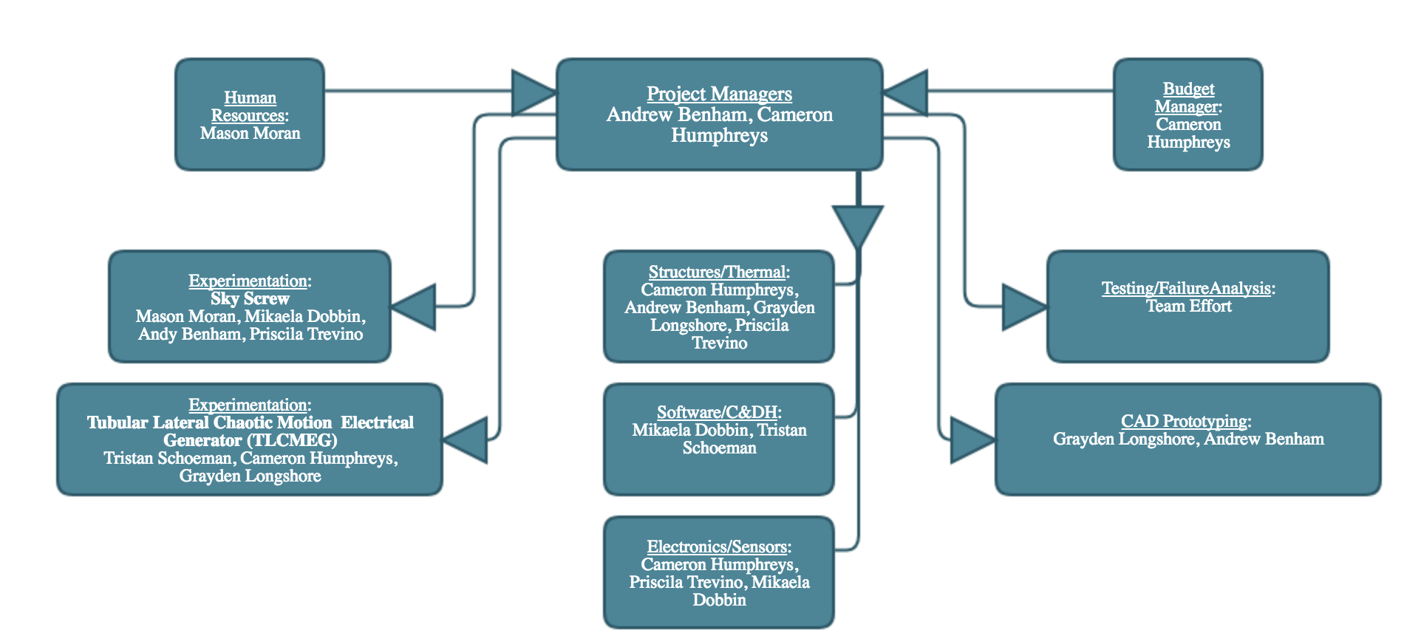4.1 Organization Chart

4.2 Schedule

Team meetings will occur frequently throughout the week, and are designed to promote efficiency and flexibility. The team aims to have as many allotted meeting periods as possible, where team members can join and leave as necessary for classes and other obligations. This means that the majority of the team’s free time can be used for work if necessary, but leaves the door open for other endeavors.To prevent overworking and encourage productive work days, regular meetings with the HR department will occur throughout the semester.

Mon/Wed/Fri- 14:00-17:00 Tue- 11:00-14:00 Thur- 19:00-21:00 Sun- 12:00-15:00

|  |  |
| --- | --- |
| Deadline | Milestone |
| 09/30/2017 | CAD Structures Completed. |
| 10/01/2017 | All Hardware Purchased and Recorded. Budget Review. |
| 10/05/2017 | All CAD Designs Finalized, Remaining Parts Ordered. |
| 10/15/2017 | Prototype Structure, SkyScrew, and TLCMEG Completed. |
| 10/17/2017 | Structure Completed with Basic Electronics Installed. |
| 10/19/2017 | Full Product Complete, Testing Begins. |
| 10/24/2017 | Impact and Power-Production Testing Complete. |
| 10/26/2017 | Cold Testing Complete. Issues Found In Testing Recorded and Addressed. |
| 10/30/2017 | All Testing Complete, BalloonSat Weighed and All Technical Specifications Met. |
| 11/02/2017 | Aesthetics Perfected, BalloonSat Officially Weighed-In and Ready for Launch. |
| 11/11/2017 | Launch day. All systems checked and ready, mission begins. |
| 11/14/2017 | Data and mission analysis begins. |
| 12/06/2017 | Have data analysis and failure analysis completed |
| 12/09/2017 | Design Expo, 1st draft of Rev D, Team video |
| 12/12/2017 | Final BalloonSat presentation |
| 12/16/2017 | Final Rev D |

**5.0 Budget & Weight**

|  |  |  |  |
| --- | --- | --- | --- |
| **Part** | **Quantity** | **Price** | **Component Weight** |
| Arduino Uno | 2 | Provided by COSGC | 139.42g |
| GoPro Hero4 | 1 | Provided by COSGC | 73.58g |
| 4GB Micro SD Card | 2 | Provided by COSGC | Included in Arduino Uno |
| 32 Micro SD Card | 1 | Provided by COSGC | Included in GoPro Hero4 |
| Pressure Sensor | 1 | Provided by COSGC | Included in Arduino Uno |
| Temp Sensor (ext) | 1 | Provided by COSGC | Included in Arduino Uno |
| Temp Sensor (int) | 1 | Provided by COSGC | Included in Arduino Uno |
| Humidity Sensor | 1 | Provided by COSGC | Included in Arduino Uno |
| Heater | 1 | Provided by COSGC | 36.49g |
| 3 Axis Accelerometer | 1 | Provided by COSGC | Included in Arduino Uno |
| Foam core | 1062 cm² | Provided by COSGC | 65g |
| Insulation | 1062 cm² | Provided by COSGC | 44g |
| 9V Batteries* | 7 | $50 | 240.8g |
| Copper Magnet wire | 1 | $25 (Amazon) | 28g |
| Magnets | 2 | $18 (Amazon) | 23g |
| Dry Ice* | 1 | $20 King Soopers | Not flown |
| PVC Tube | 1 | $10 McGuckins | 34.5g |
| Resistor | 1 | Free (Project Depot) | 0.2g |
| Capacitor | 1 | 25¢ | 0.3g |
| DC Motors | 6 | $25 (Amazon) | 17g |
| Bearings | 8 | $15 (Amazon) | 27g |
| Metal Tubes | 3 | $10 | 20.2g |
| Gears | 2 | Free (Project Depot) | 11g |
| SkyScrew | 1 | Free ( PLA purchased by Mason) | 53.5g |
| Center rings | 2 | Free (Project Depot) | 15g |
| Endstops | 2 | Free (Project Depot) | 20g |
| Tape | 40 cm | Free (Project Depot) | 40g |
| Operational Amplifier | 1 | $2 | 10g |
| Wires | 53 | Free (Project Depot) | 100g |
| **Total** |  | **$175.25** | **998.99g** |

*Batteries and dry ice are team-funded.

*Team ScrewUp was granted additional weight up to 1,000g

**6.0 Testing & Safety**

6.1 Test Plan

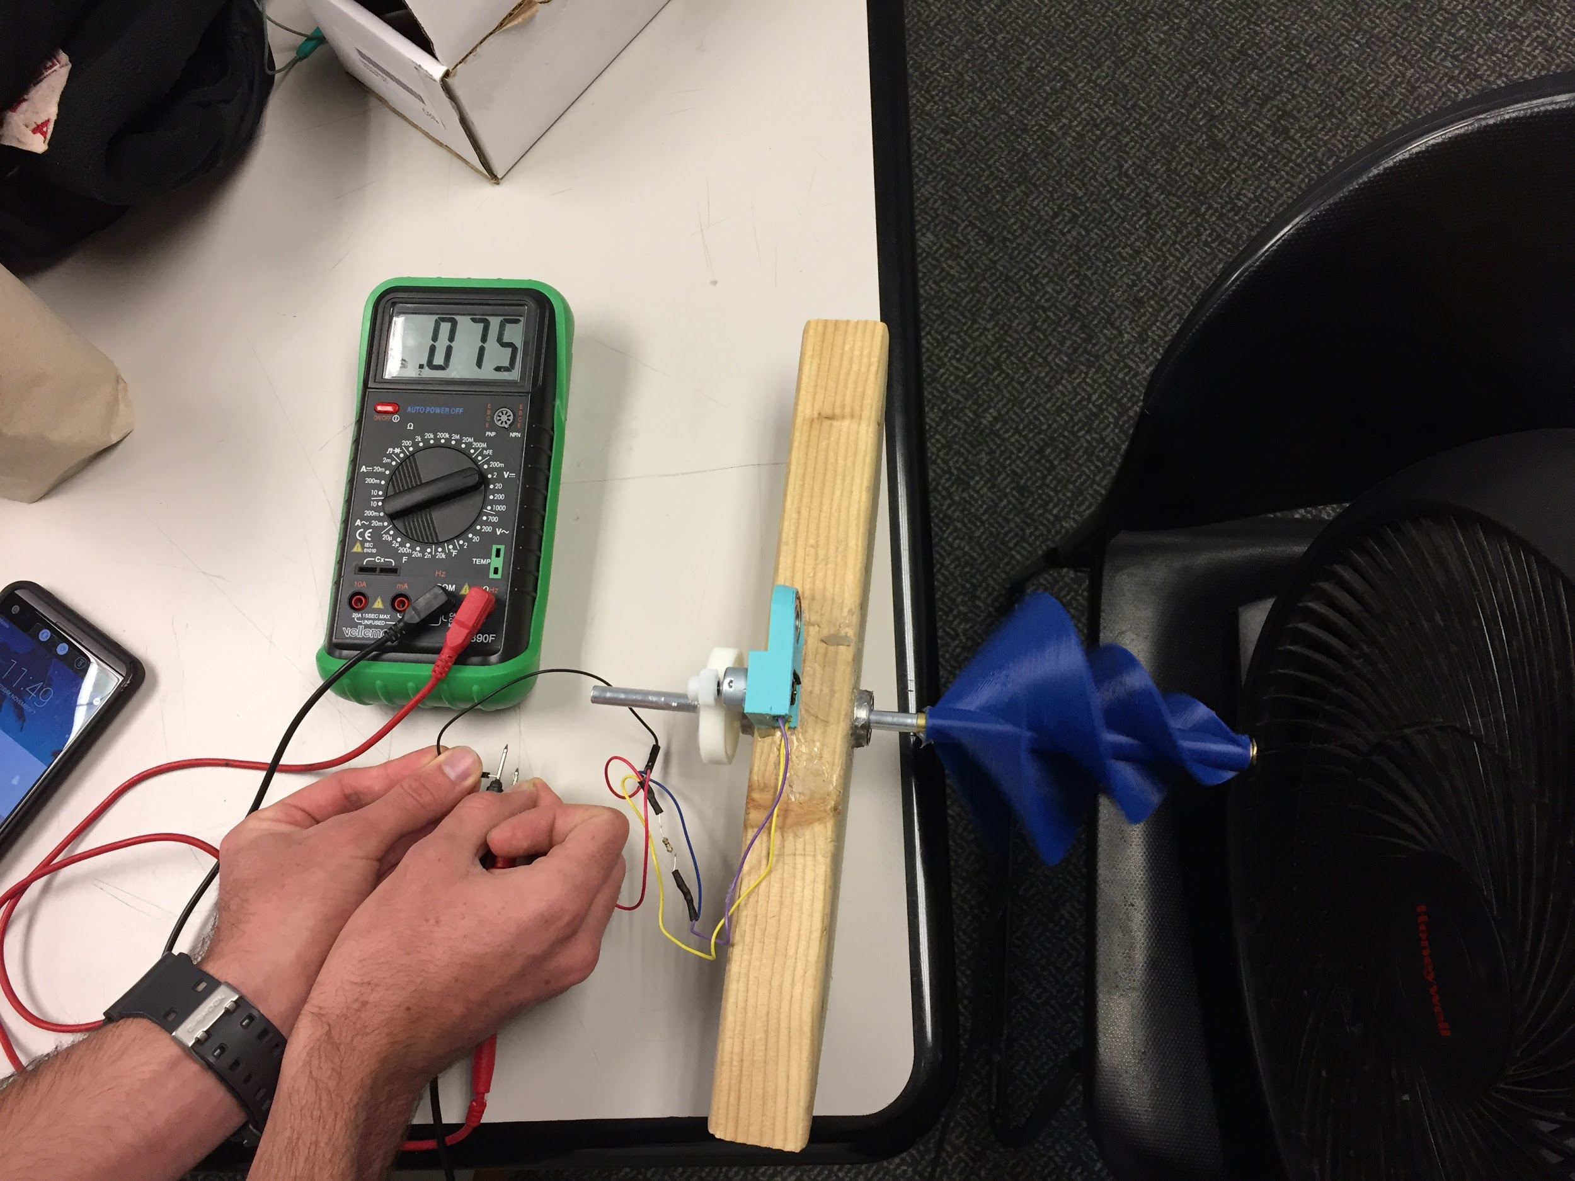Each power generating system will have its own unique testing protocol. Because the SkyScrew functions by the power of the wind, it is necessary to simulate such an environment with similar wind flow as the ascent for testing. The objectives of testing the SkyScrew are to prove that the screw can spin and, if it does spin, to see how much energy is produced. The first method of testing is hanging the BalloonSat under a box fan with a wind speed of about 4.47 m/s (16km/h) to test the spin of the SkyScrew and to emulate the ascent of the flight. The SkyScrew was tested by a fan with wind speed verified by anemometer at 5 m/s. To perform this process, the SkyScrew was loaded into a custom made test rig, comprised of a block of wood approximately 3.5 cm thick (*Figure 8*). Protruding from the wood block on either side are 9 mm bearings. The 3D printed screw is fixed to an aluminum shaft whose radius is approximately 4.5 mm. The aluminum shaft is inserted into the bearings, and on the end opposite the screw, a gear is fixed to the shaft. A motor was fixed to the block itself with a different sized gear attached to it, close enough in proximity to the shaft gear for gear mesh to occur. In order to deduce what gear ratio Team ScrewUp would use for the final iteration of the SkyScrew system, several different gear ratios were tested. The wind speed of 5.36 m/s was kept at a constant. Several different motor configurations were combined with gear ratios to find the best fit. The final gear ratio used is approximately 1:3.8. The motor used is a 3V motor with a 3600 RPM rating.

*Figure 8 - Testing rig for SkyScrew*

The TLCMEG requires an intense, rocking motion for it to function properly. While the BalloonSat ascends, it will move back and forth, causing the TLCMEG to generate electricity as it rocks back and forth. As the BalloonSat descends, the rocking motion will be more intense due to a higher velocity, creating more potential for electricity to be generated. The tests for the TLCMEG will be done with the purpose of simulating the descent because it is the more violent portion of the satellite’s time in the air. Initial testing of the voltage output from the TLCMEG will be done using an oscilloscope, operated by Tristan Schoeman, Cameron Humphreys and Grayden Longshore. Detailed testing will be done in 50mV ranges at different magnet speeds through the coil using the oscilloscope. After this is done, the oscilloscope values will be compared to the voltage and current measurements on the Arduino in order to ensure that they are correct.

Along with testing the electricity-producing components, the team will perform a whip test, a drop test, and a dry ice test. These tests are to ensure that the BalloonSat will survive the flight and in order to pass these tests, the BalloonSat should not have any major damage done to the box. The whip test shall be done in the field behind the business building to make sure that there is no one in the vicinity in the event that the box isn’t secured well enough to the rope. The whip test is is to make sure the box will stay in place on the rope and guarantee the structural integrity of the components in the event of intense sudden motion. The drop test will be carried out at several different heights with a similar weight as if the sensors and electricity-producing components were actually in the box. After each of these tests, the box will be inspected for tears, holes or any structural failures in order to evaluate whether the design is appropriate. Finally, the dry ice test is to make sure the heating components work as they should and to see what happens to the components when introduced to freezing cold temperatures. To test these, the team will purchase some dry ice and put the box and the dry ice in a cooler for about an hour. This specific time frame is because that’s around the amount of time the satellite will be in the extreme cold temperatures. There will be two mission simulation tests. The first one will be done in class and run all of the components Team ScrewUp have assembled for 3 hours. The second one will be after the box has been finally assembled in order to do a full system check for 3 hours while a team member is spinning the screw and shaking the box at intervals.

The following graphs depict current and voltage data from the TLCMEG when shaken on regular intervals across a three-hour mission simulation.

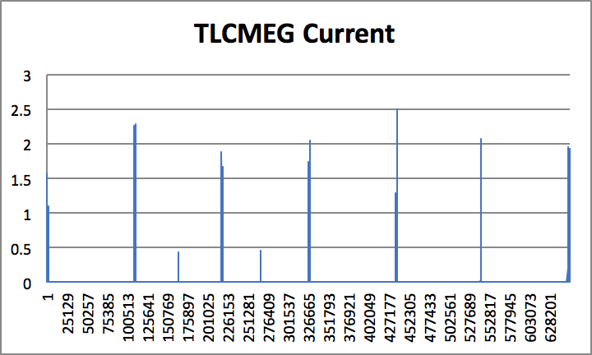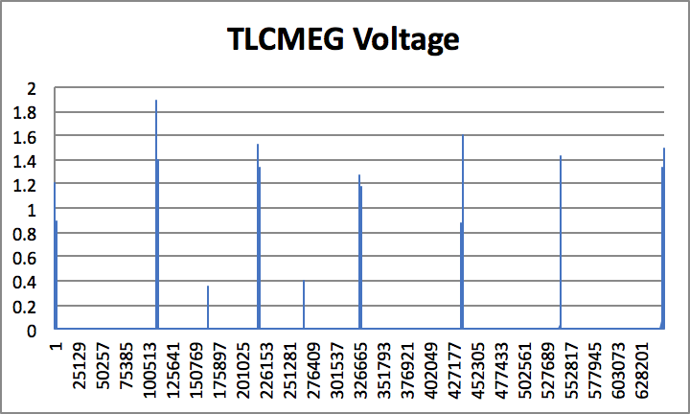

SkyScrew Mission Simulation Data

The following graphs show data for the SkyScrew system generated by sporadically spinning the screw for the first 30 minutes. The second graph was then filtered with the Team’s MATLAB function.

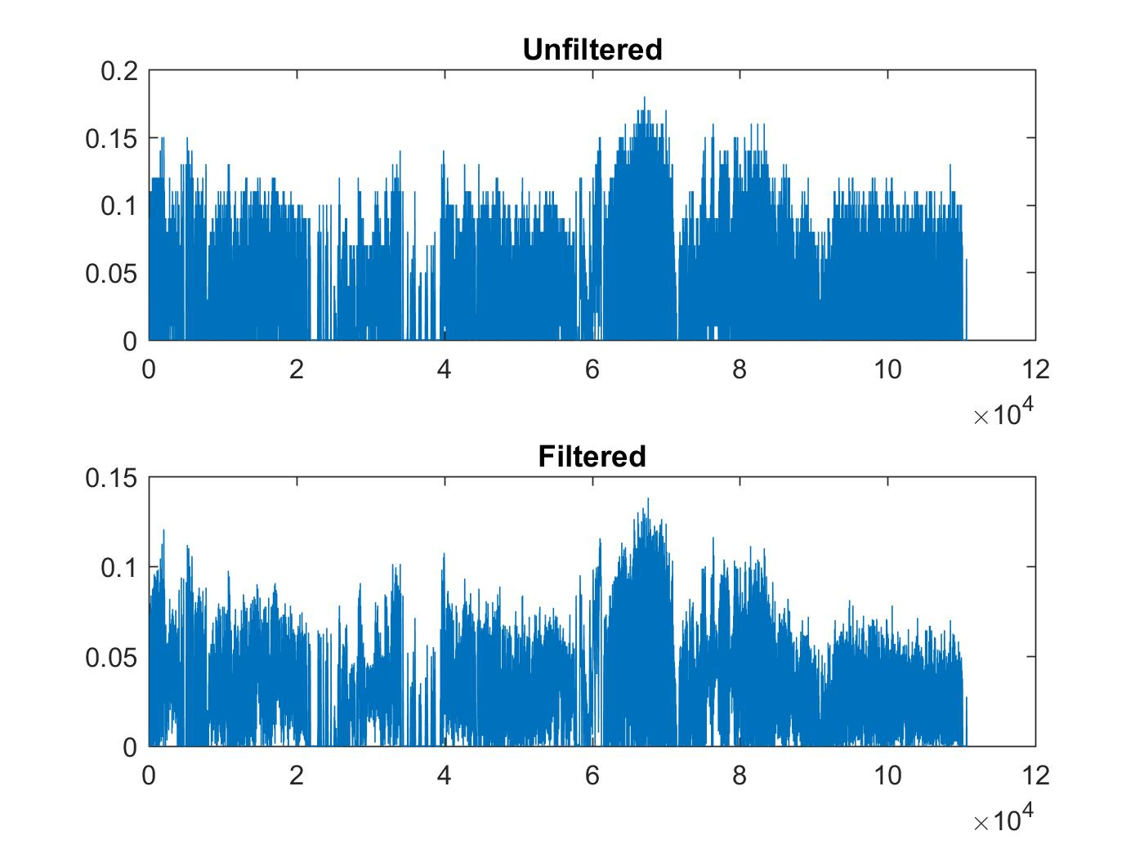

Environmental Sensor Testing

The sensors attached to Arduino 1 shall be tested and calibrated. With an SD card loaded into the open log, the following tests will be recorded onto the card.

1. The humidity sensors will be breathed on twice
2. The pressure sensor will be sucked on twice
3. Both temperature sensors will be touched for 5 seconds each
4. The arduino will be oriented in the x-axis orientation for 10 seconds
5. The arduino will be oriented in the z-axis orientation for 10 seconds
6. The humidity sensor will be breathed on twice
7. The pressure sensor will be sucked on twice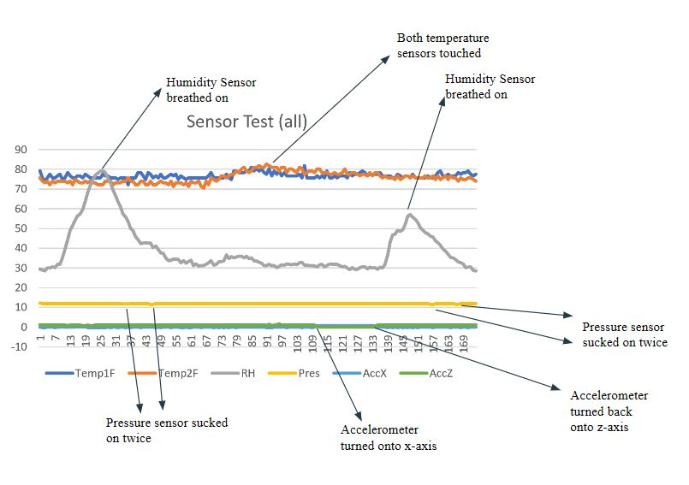.

*Figure 9 - Sensor Test Graph*

Following these test, the SD card will then be removed and data will be uploaded and graphed on a computer. The values collected will be compared with the current room temperature, pressure, and humidity of the room. If the values from the sensors are the same, the sensors have been successfully tested. If the accelerometer shows z values close to 1 and x values close to 0 when oriented on the positive z-axis and conversely when oriented on the positive x-axis, the accelerometer has been successfully tested.

6.2 Safety

Injury prevention is a top priority for Team ScrewUp. When handling dangerous tools, such as the soldering iron or any other hardware tools, work will be done at a safe and moderate pace to ensure there’s as little chance of injuring themselves or those around them. They will also make sure the tools they’re using aren’t damaged and know how to properly use each tool. If, for some reason, a team member doesn’t know how to use a tool or the machinery at the ITLL, they will ask for help from the ITLL staff. Also, during the drop test of the BalloonSAT for durability, the team will check their surroundings to make sure that no pedestrians are around them

6.3 Structural Test Results

6.3.1 Drop Test

Team ScrewUp performed the drop test at the ITLL balcony. The box was dropped approximately 2 stories. To simulate the weight of the components that would be in the box, all internal components of the box were removed and weighed. Rocks were gathered that amounted to approximately the same weight of the internal components and placed in a bag and taped together and secured in the box. After the test there was no major structural damage to the box and Team ScrewUp did not need to make any changes to the design of the box.

6.3.2 Whip Test

Team ScrewUp performed the whip test outside of the ITLL in the Koelbel field. The box was attached to the flight string in the same fashion that will be used on launch day. The box was swung around and whipped back and forth. This test was successful and there was no structural damage to the box, SkyScrew, or its shaft and bearing connections.

6.3.3 Stair test

For the stair test team ScrewUp kicked the BalloonSat down two flights of stairs with the aforementioned simulated weight in the box. The results from this test aligned with the drop test in that there was no major structural damage to the box and the design of the box did not need to be altered.

6.3.4 Cold Test

Team ScrewUp successfully performed the cold test of the BalloonSat, all the internal components of the Sat were activated and placed within a styrofoam box with approximately 15 lbs of dry ice. The test ran for 90minutes reaching an external temperature of -33℃while the internal temperature never dropped below 0℃**.** During the test while the box was well below 0℃ the box was shook and the SkyScrew turned, both components performed nominally indicating that the BalloonSat will be able to survive the extreme temperatures encountered at high altitudes.

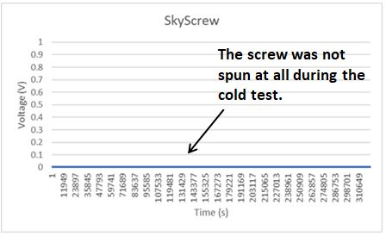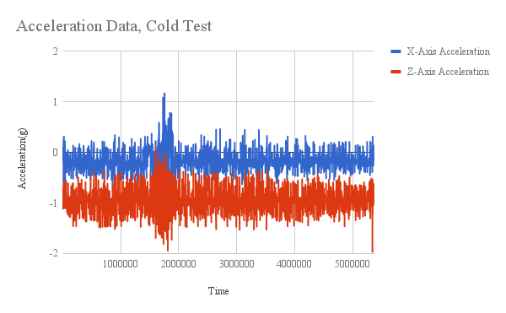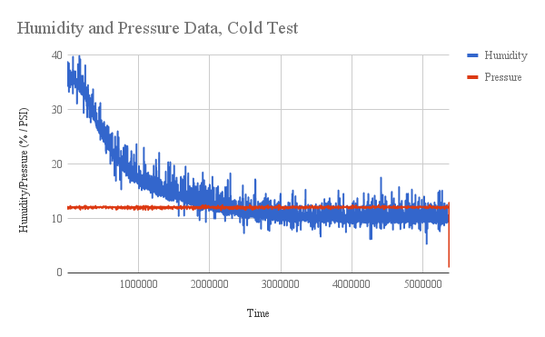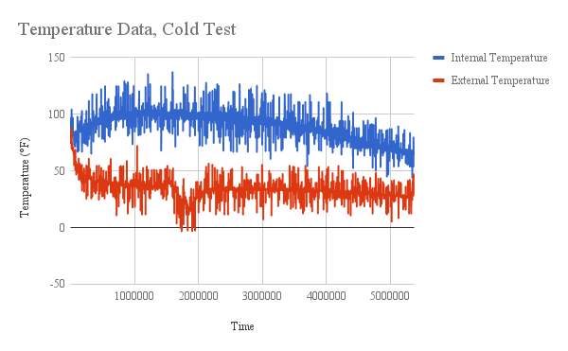

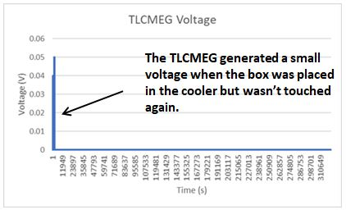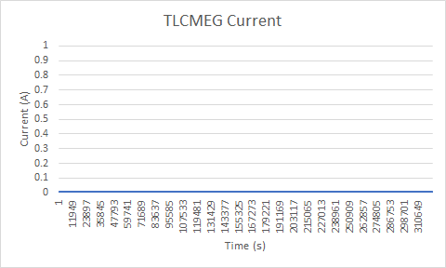

6.3.5 Camera Test

For the Camera test the GoPro was placed inside the box in the same location it will be in during flight. Then using the access port the camera was turned on and took pictures to verify its function. The camera was then turned off and removed and pictures were taken off the SD card. The pictures were clear and the camera appears to be fully functional.

6.4 Mission Simulation

Team ScrewUp verified that all systems were operational and flight ready though a full hour and a half mission simulation. In the mission simulation all components that are planned to fly were placed and secured in the same spots that they will be in for the launch. Fresh batteries were used and all components activated. Then the box was sealed and attached to flight chord. During this time the SkyScrew was intermittently spun as well as the box was shook to prove that all components worked. It was also held underneath a fan to show that the increased friction from the string on the inside of the shaft was not enough to prevent spinning which it was not.

*Stair test Drop test*

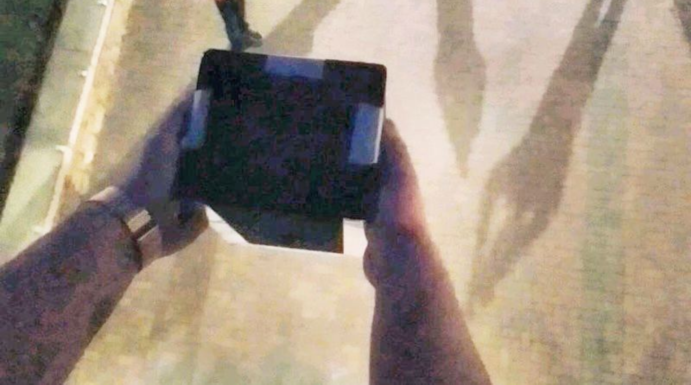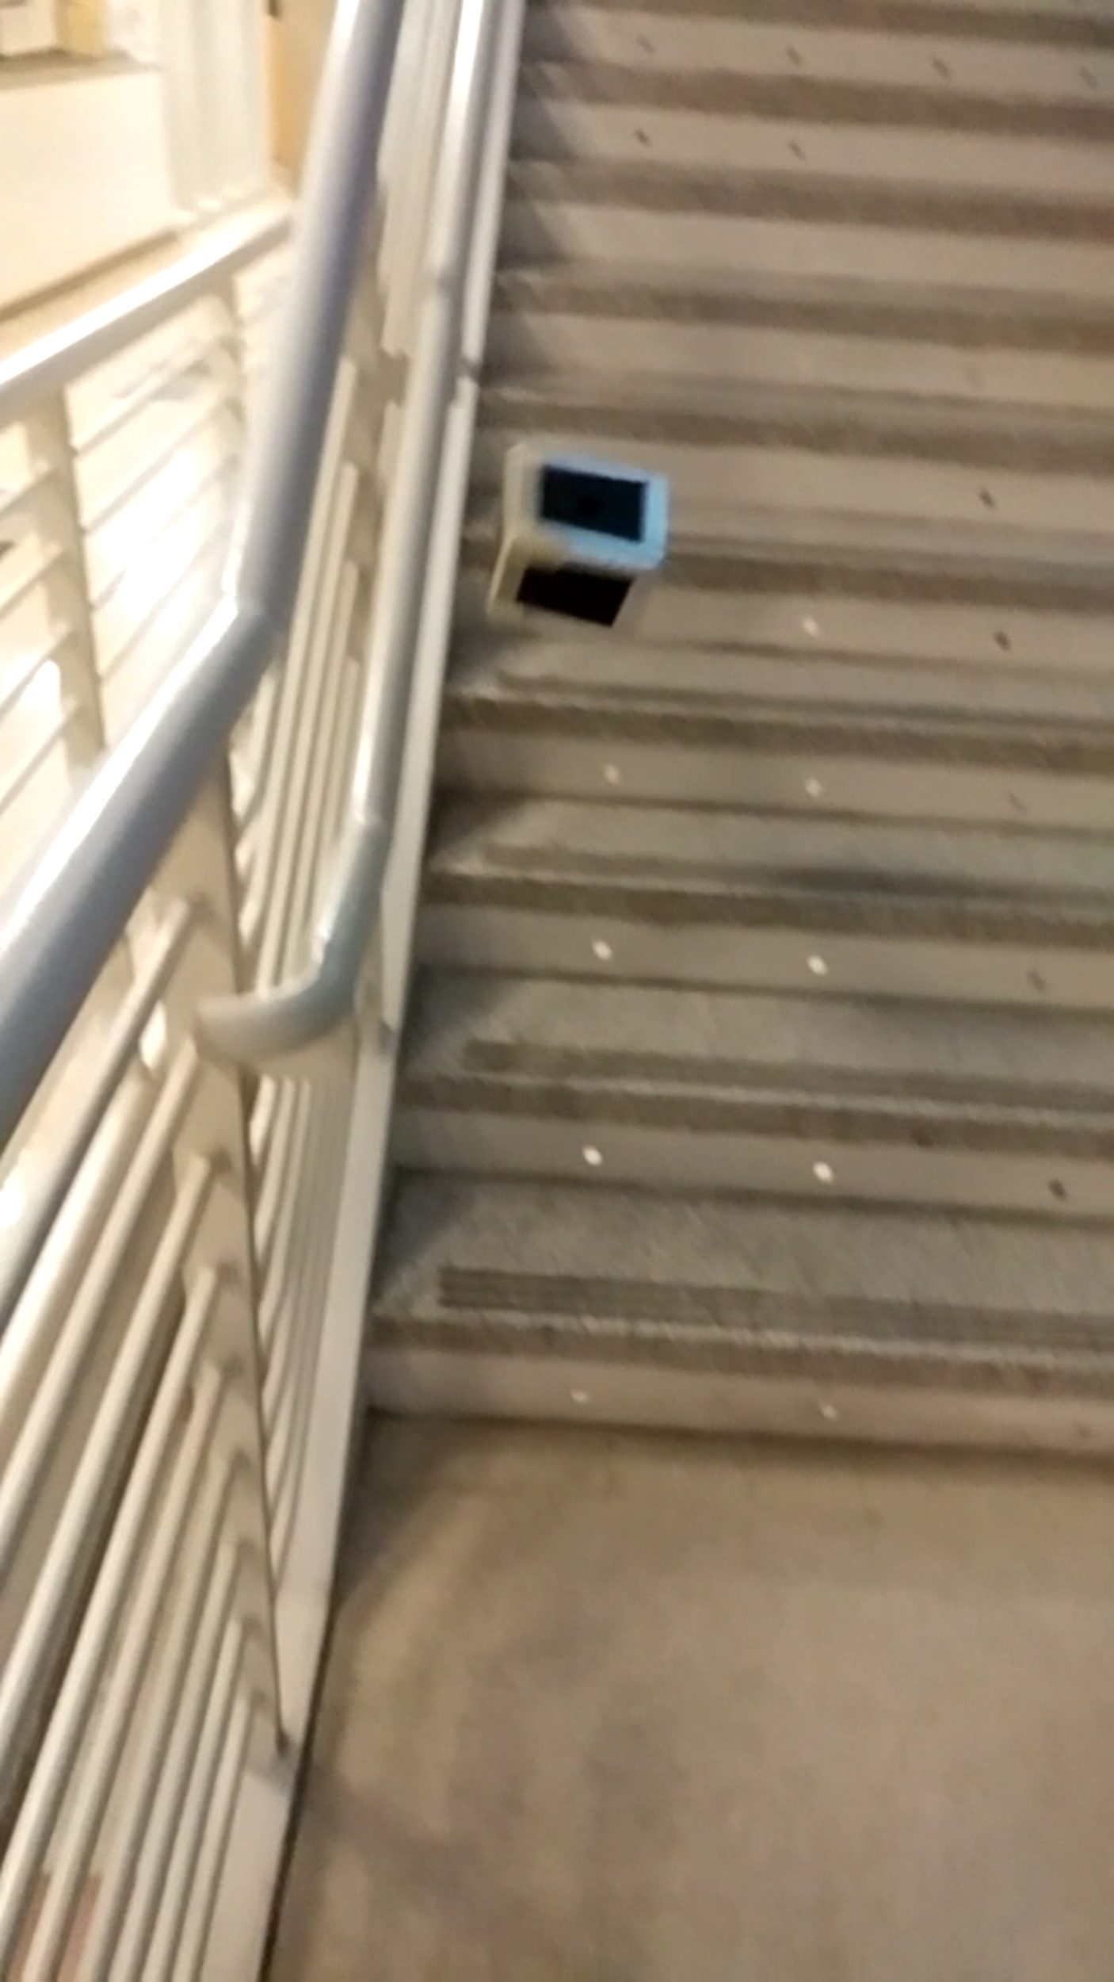

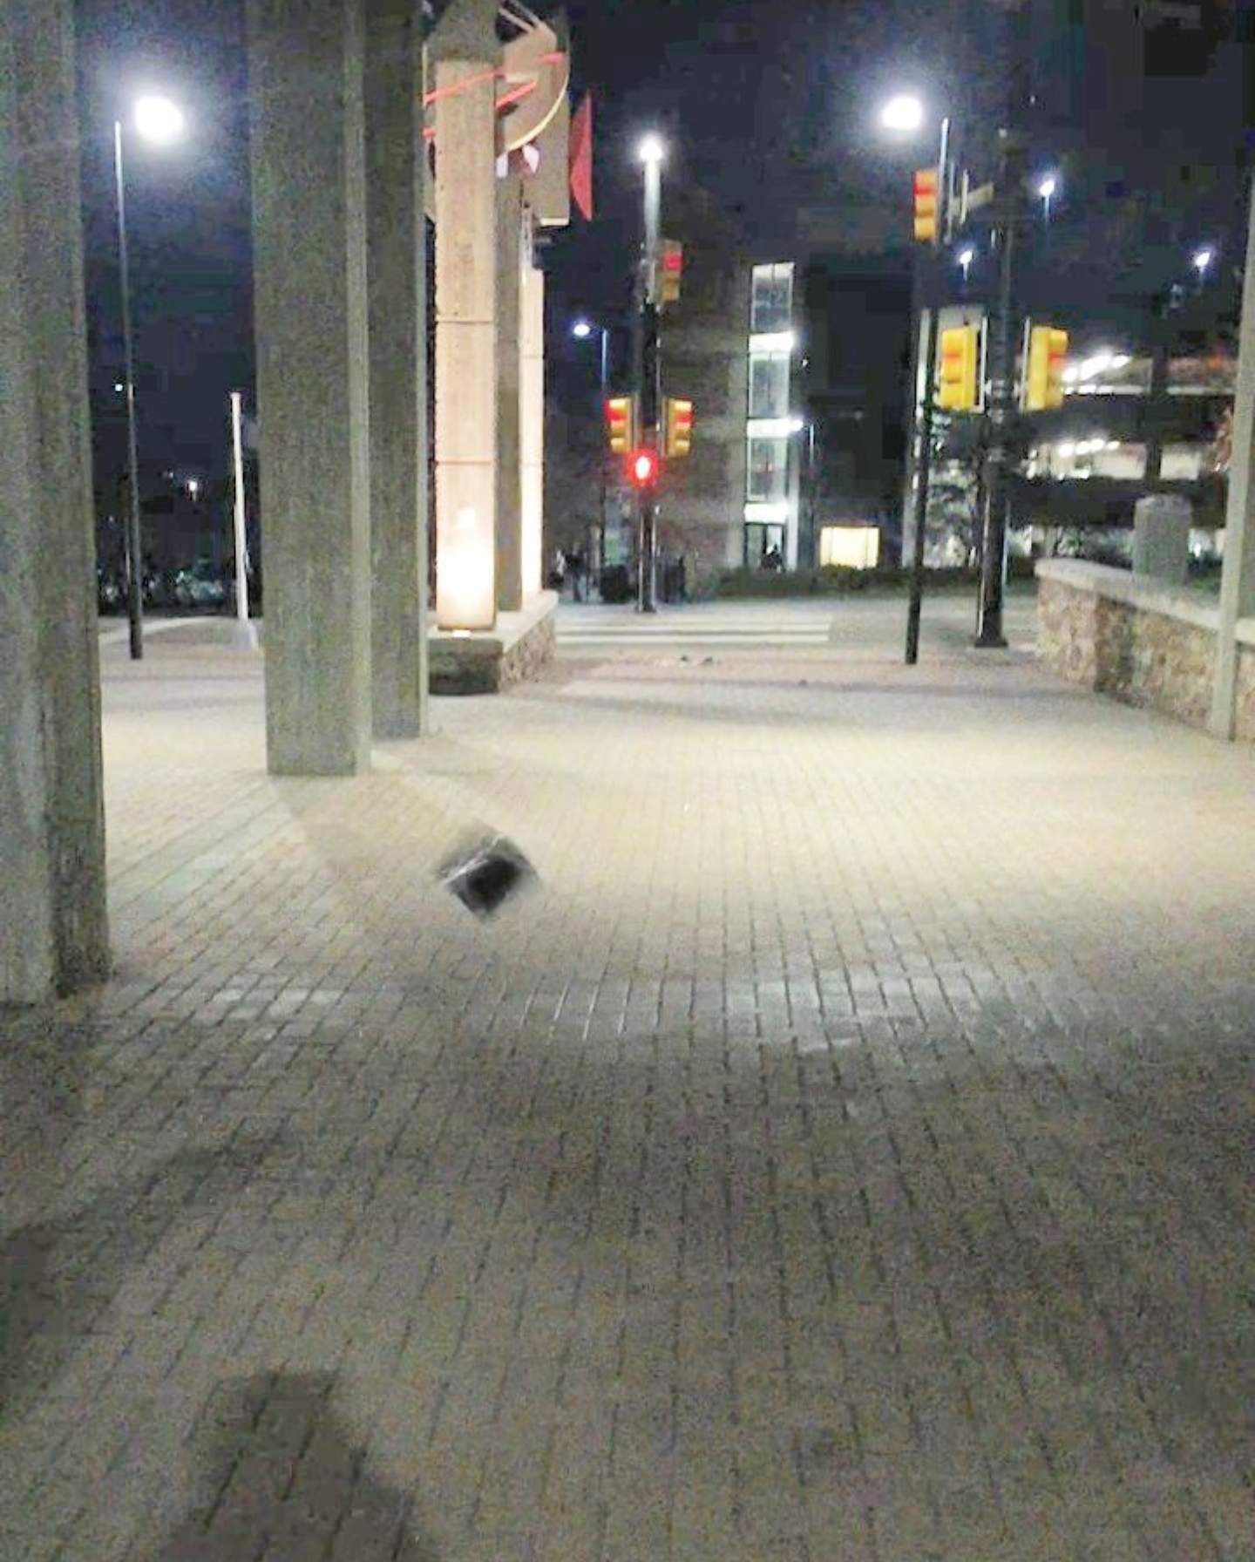 *Whip Test Drop Test*

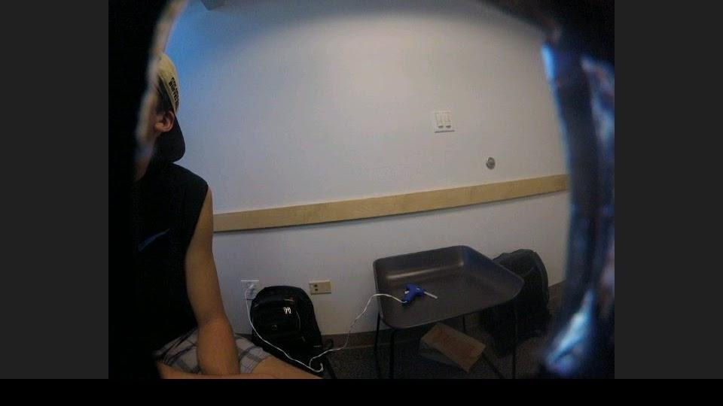

*Camera Test*

**7.0 Expected Results**

7.1 SkyScrew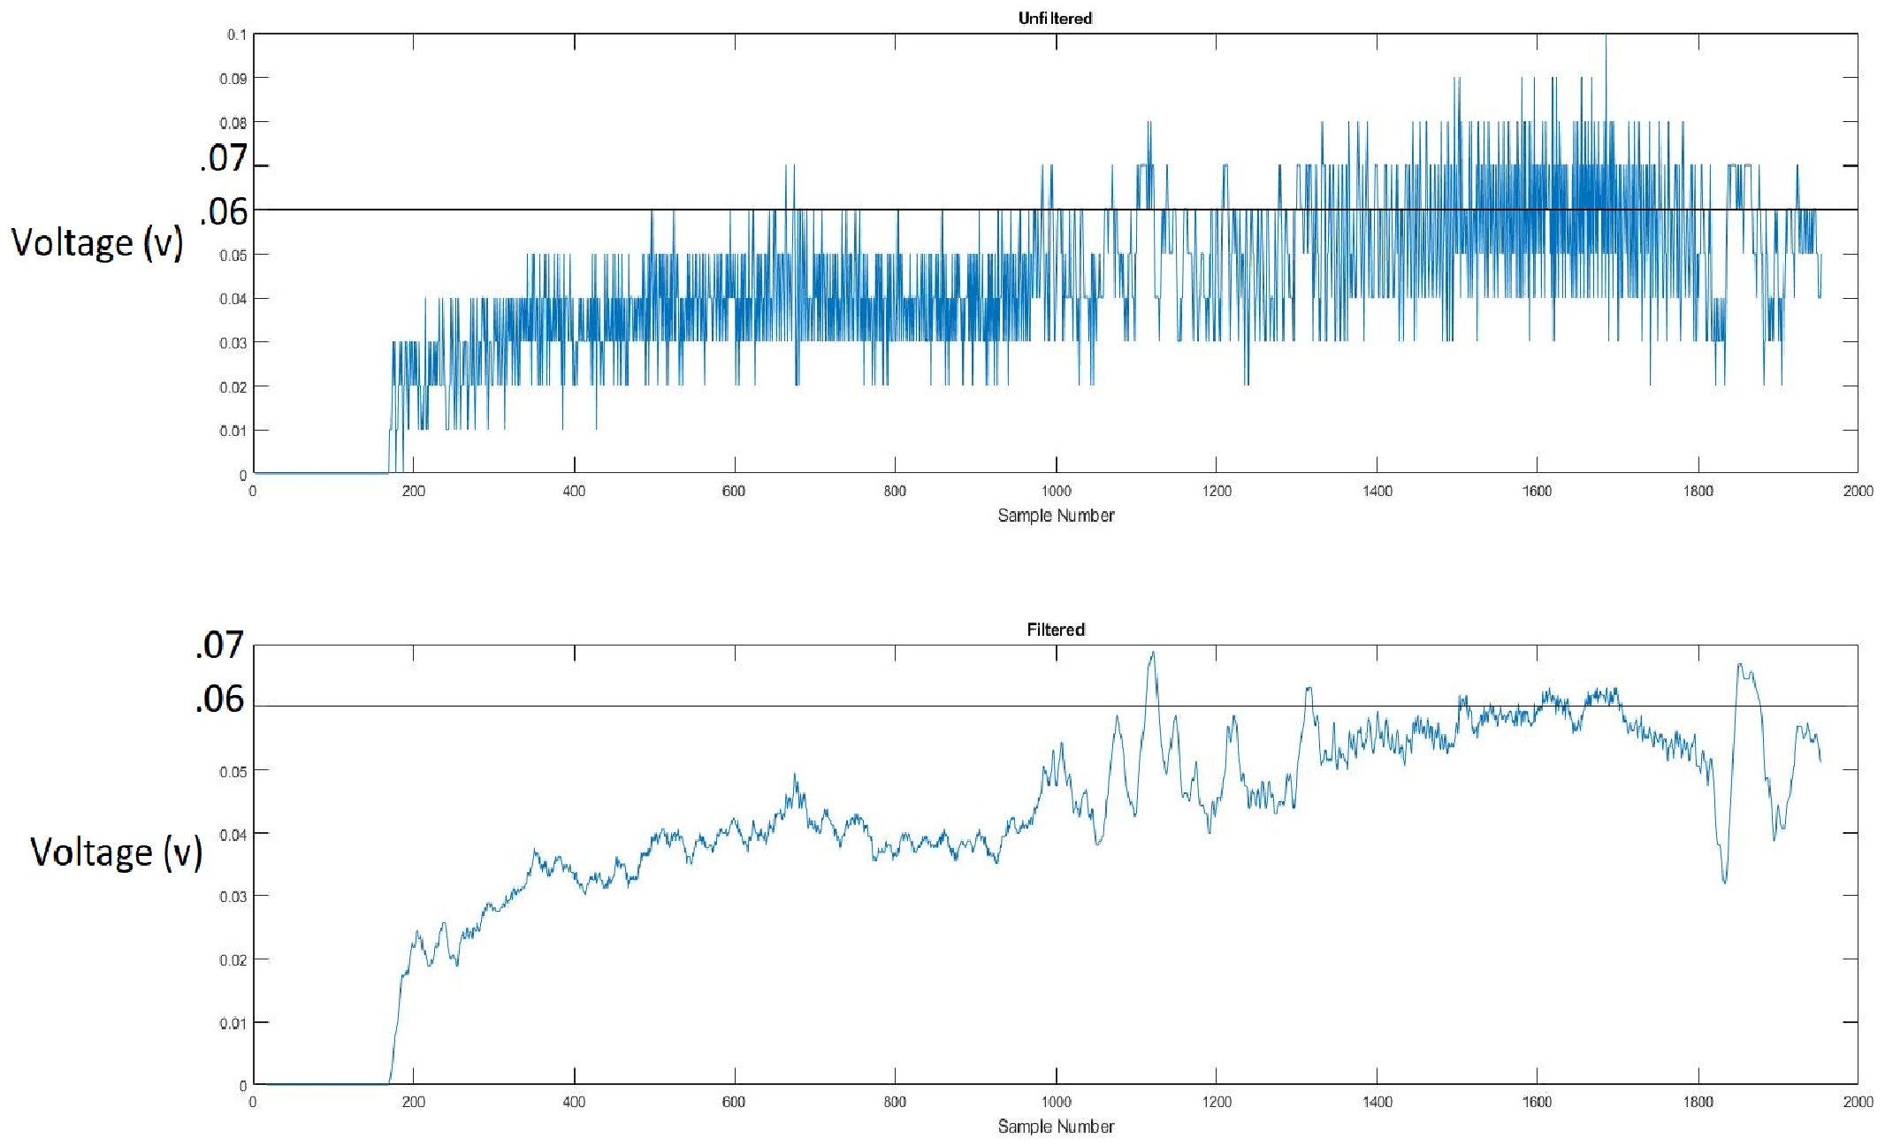

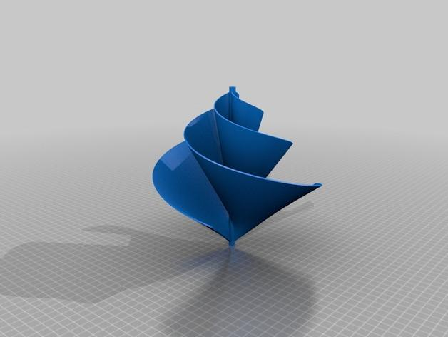

The voltage output data is taken from a 3V electric motor with a 1:3 gear ratio and Archimedes style Aerial Screw. Analog port 3 on Arduino 2 is wired through the circuit to the 3V motor and a custom code was written to process the input. The voltage values will be filtered post flight to remove the noise and make the graph look cleaner. This is accomplished using an averaging filter program written in Matlab.

*Figure 10 - SkyScrew Test and Predicted Data*

7.2 TLCMEG

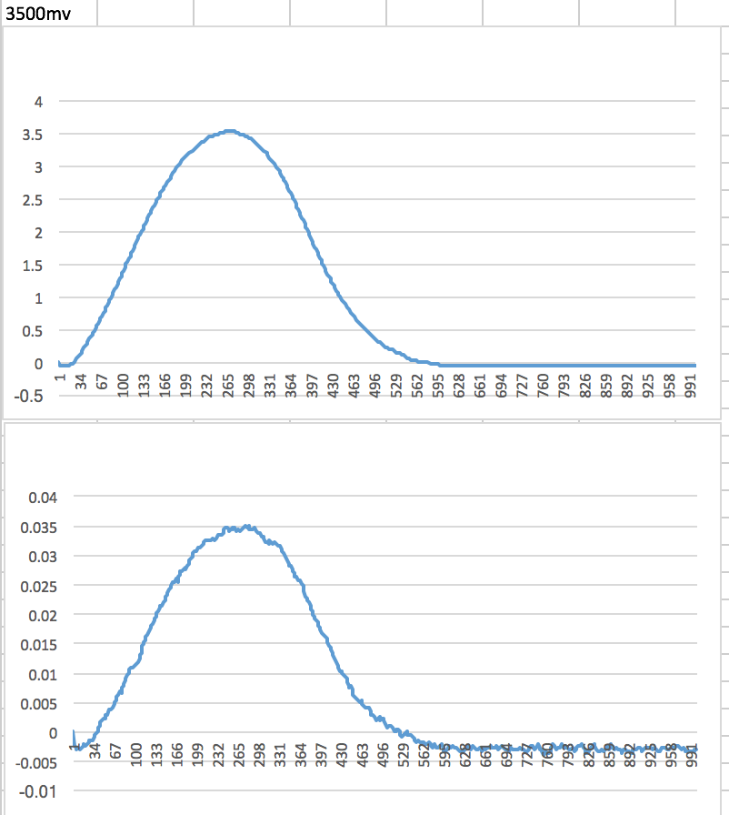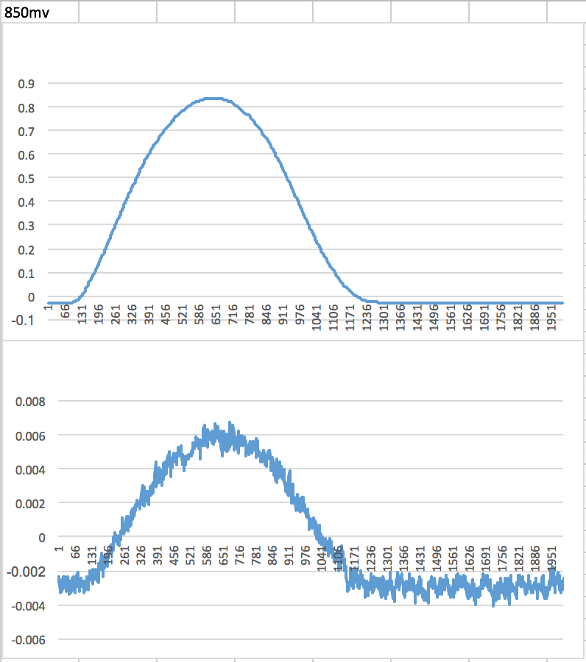Voltage output data taken from the TLCMEG. The device was directly wired to Analog port 1 and 2 on the Arduino. Analog port 1 was measuring the voltage output of the TLCMEG, after it was voltage divided. Analog port 2 was measuring the current output of the TLCMEG, after it was amplified using the operational amplifier chip.

Max Voltage: 0.850V

The experimental TLCMEG data is shown above. Slow(left) and fast(right) movement of the magnet through the tube is shown.

Max Voltage: 3.5V

7.3 Temperature Sensor

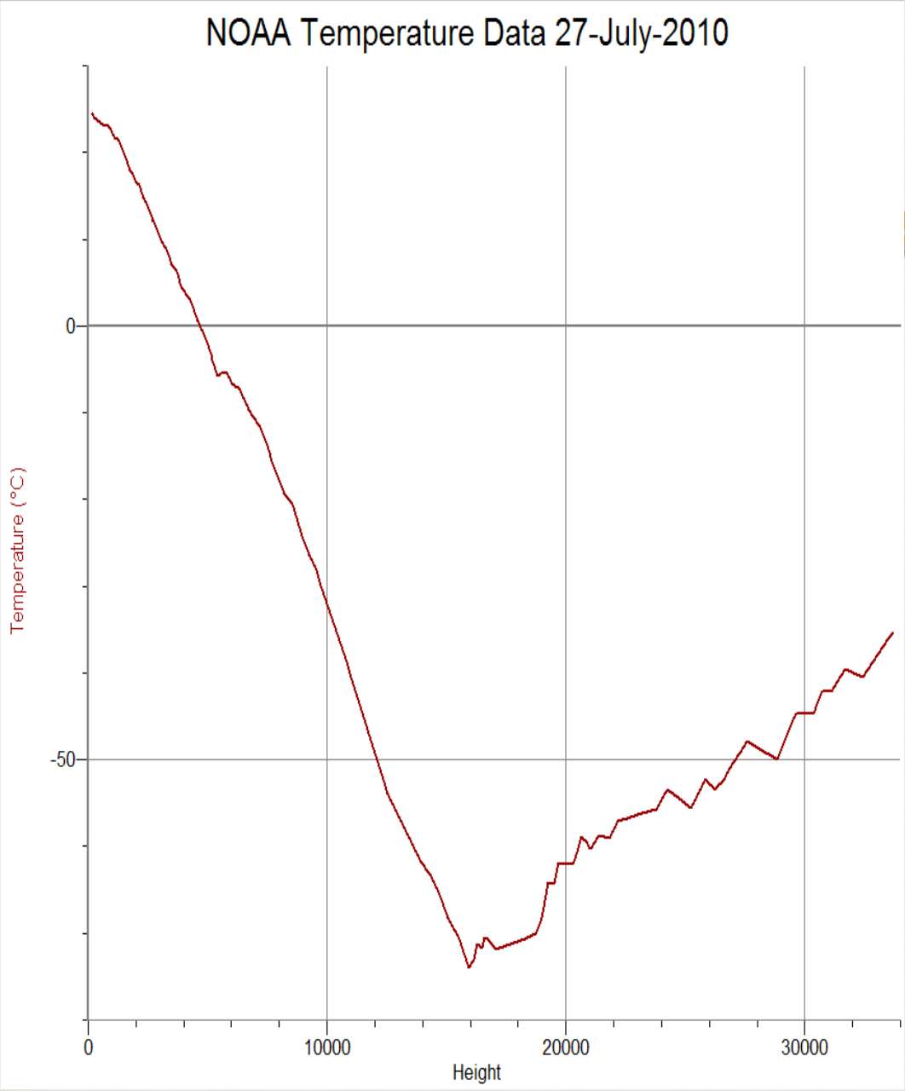

This graph illustrates that as the BalloonSat goes to 30 km, the temperature will decrease until it reaches about 13 km where the temperature starts to gradually increase. This is because in the stratosphere there is a layer of ozone molecules which absorbs solar radiation, thus heating the stratosphere. This data was taken from a NOAA BalloonSat Flight in 2010.

7.4 Pressure Sensor

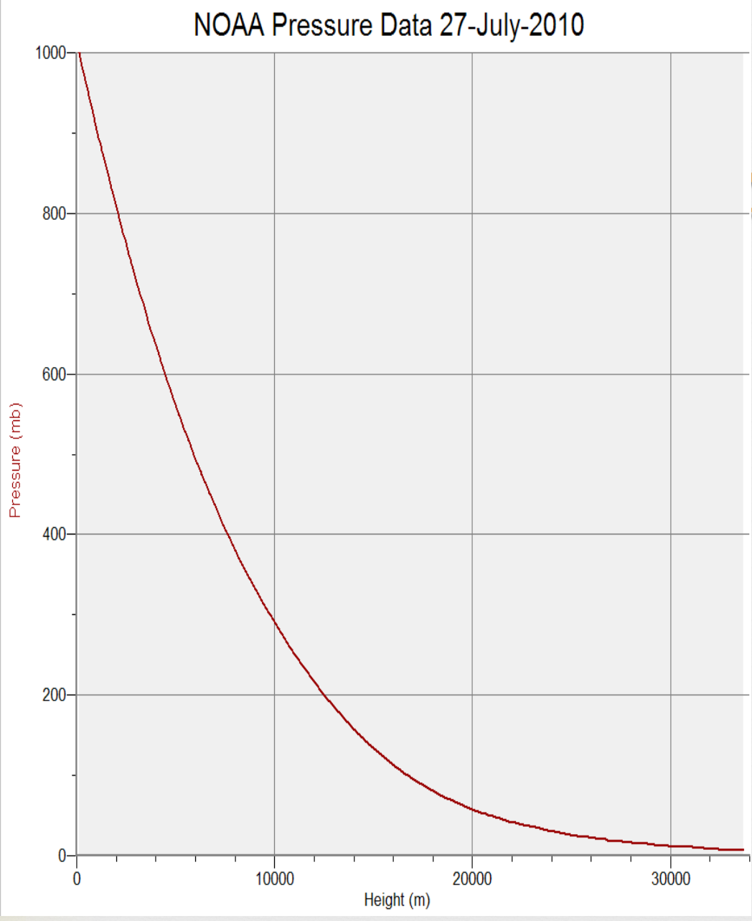

The graph above illustrates the expected data results from the pressure sensor. The expected pressure will vary inversely to altitude. As the BalloonSat reaches near-space, the pressure will approach a minimum at zero. On descent, the graph will be reflected. This data is taken from a NOAA BalloonSat flight in 2010.

7.5 Humidity Sensor

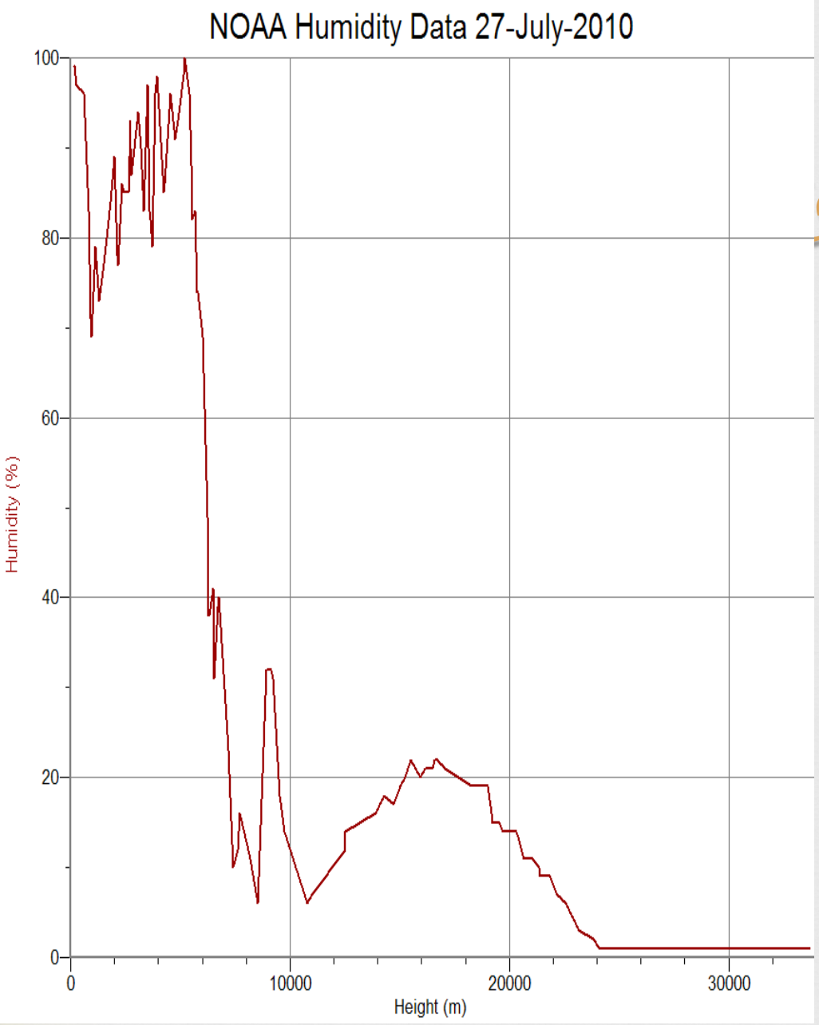

The graph above illustrates the expected data results from the humidity sensor as altitude increases. There is an initial decrease followed by an immediate increase in the first few thousand meters. This is due to potential cloud cover as the balloon rises. Ultimately, the humidity decreases as height increases because the higher in altitude the balloon goes, the thinner the atmosphere becomes. As atmosphere becomes thinner, the amount of water vapor it holds decreases, thus resulting in a lower percentage of humidity.

7.6 Accelerometer

The graph above illustrates the expected data results from the accelerometer sensor measured against time. It is expected that the data will show greater magnitudes of acceleration during the initial launch, the violent burst of the balloon followed by descent as the satellite will fall twice as fast as it rises, and finally when the satellite lands. This data was taken from Team ICARUS ASEN 1400 Spring 2015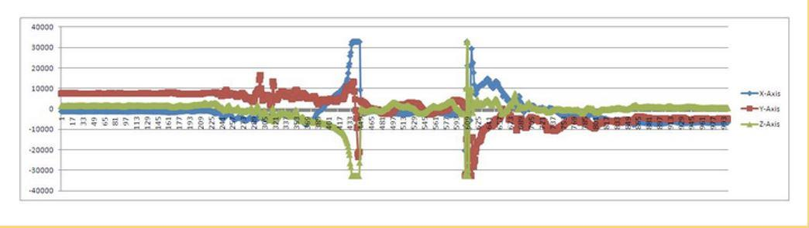

**8.0 Launch and Recovery**

8.1 Launch Plan

On the morning of Saturday the 11th, the team will meet at the ITLL at 4:30 to allow for a buffer in the schedule. Leaving no later than 4:45, Team ScrewUp will leave for the launch site. Upon arrival, Mikaela Dobbin will turn the Balloon Sat on and then off to make sure everything is powered up as it should be. Afterwards, Mason Moran will thread the the string through the box, following the specific design requirements of attaching the box to the string. Once all the final checks have been made, Tristan Schoeman will hold the box, power it on as well as the GoPro, and then release the box as the balloon starts to rise.

8.2 Data Recovery

Once the team recovers the box, they will take it back to the ITLL to analyze the data. The SkyScrew Voltage/Current data will be run through a MATLAB filtering code to clean up the noise from the motor and make the graph cleaner. Secondly, the TLCMEG data will be collected and analyzed. If the current data for TLCMEG has too much noise such that it is unreadable, Team ScrewUp will use the database of voltage values to their corresponding current values when the magnet is moved at different speeds through the coil (50mV increments). This database will be used to generate a corresponding current graph from the database that was generated using the voltage values from flight.

8.3 Condition of Payload at Landing Site

The condition of the BalloonSat at the landing site (below) shows was that there was no major damage done to the structure of the box. However the SkyScrew shaft was no longer attached since the shaft was found broken off at the top of the box.

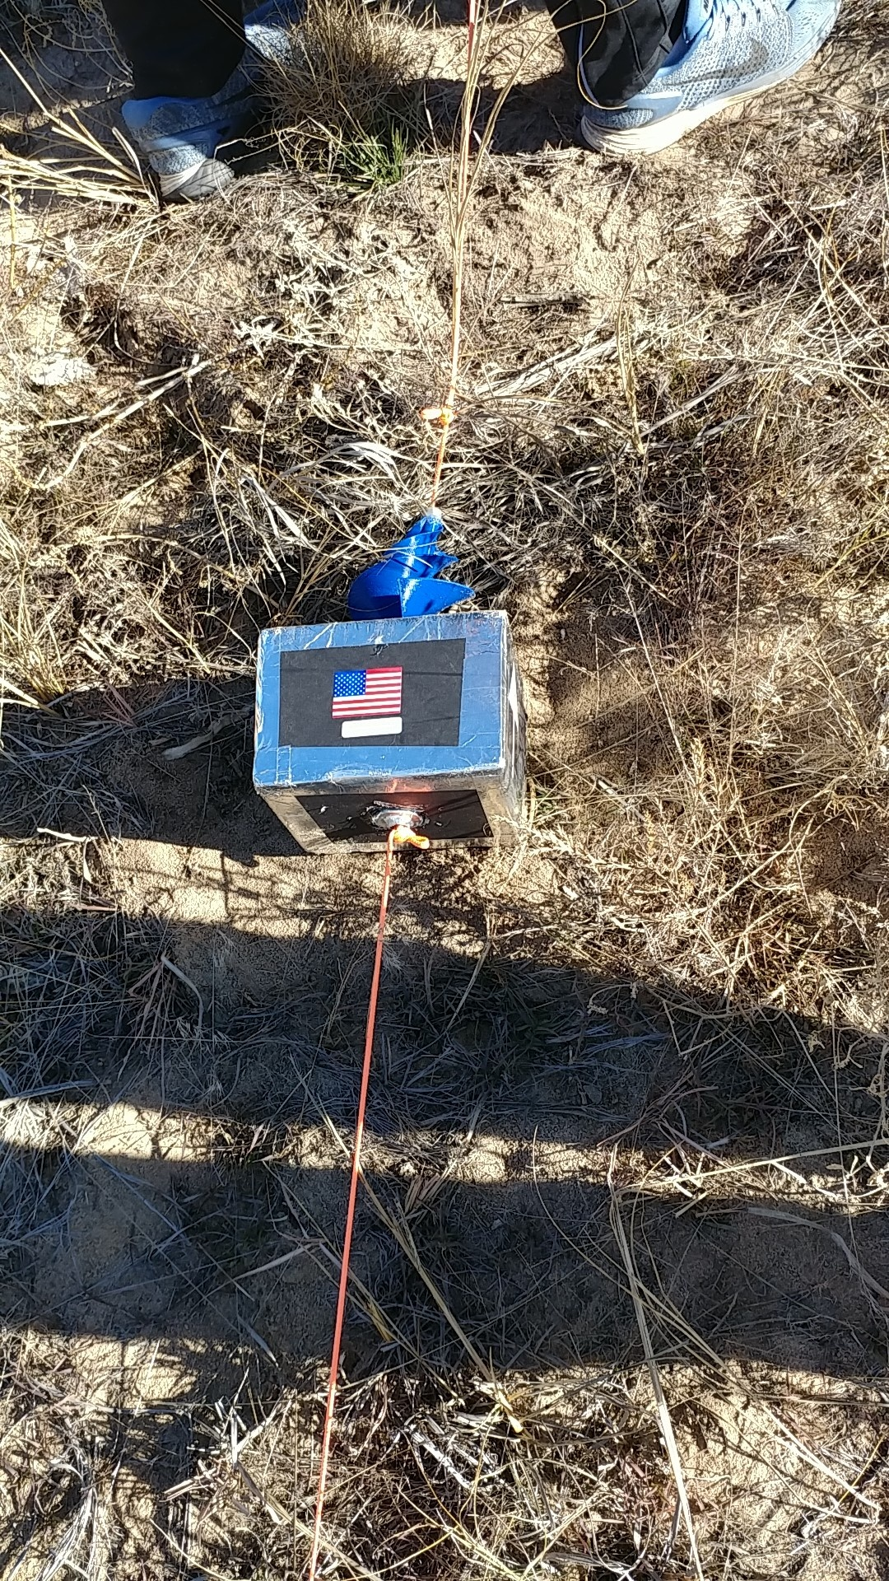

**9.0 Results, Data Analysis, Failure Analysis, and Conclusions**

9.1 Sensor Data Results

*9.1.1 Temperature Sensor Data*

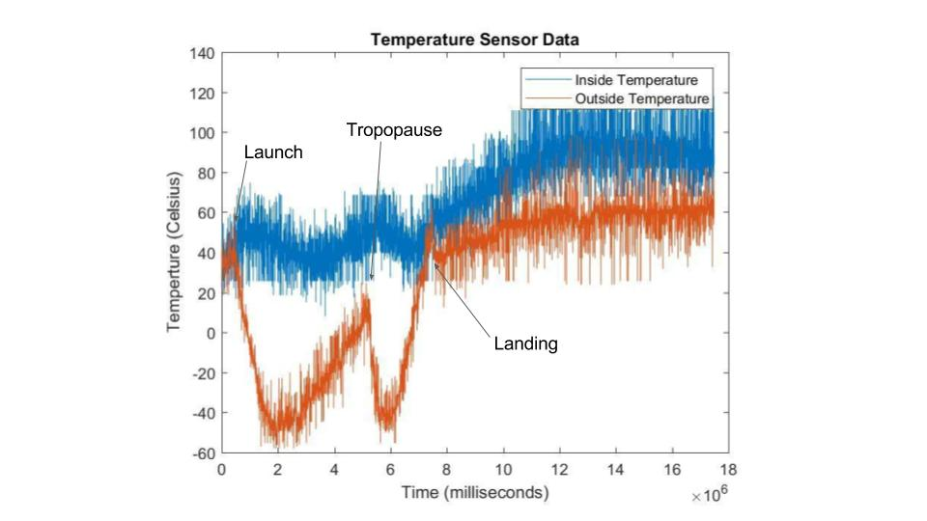

As expected, the internal temperature data, shown above by the orange line, never reached below 10 degrees Celsius, complying to the the ASEN 1400 flight requirements. Furthermore, it can be seen that as the balloon increased in altitude, the expected outer temperature was observed. The temperature first decreased and then increased, caused by the tropopause and this behavior was echoed on the descent.

*9.1.2 Humidity Sensor Data*

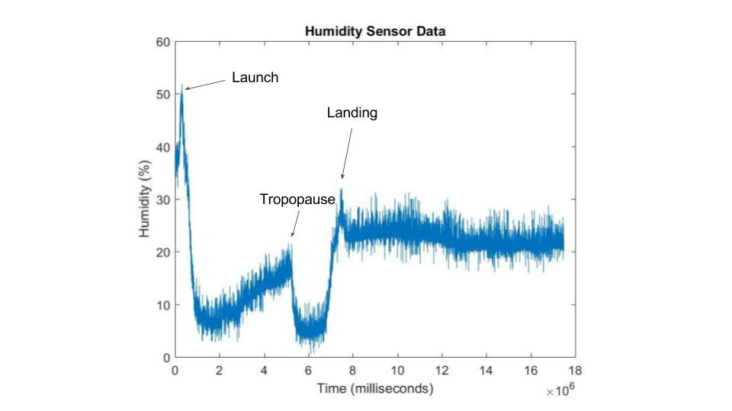

As expected, the humidity sensor data followed the similar trend as the outer temperature data. There is an initial decrease followed by an immediate increase in the first few thousand meters.

*9.1.3 Pressure Sensor Data*

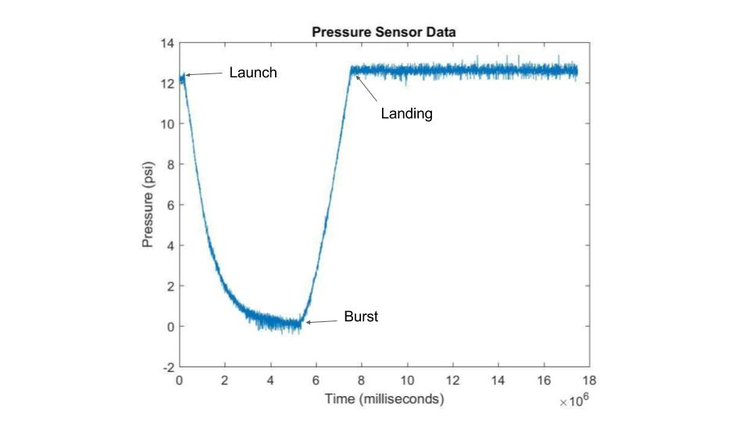

The pressure data received from flight also is as expected. As altitude increases, the pressure decreases and then increased again after burst.

*9.1.4 Accelerometer Sensor*

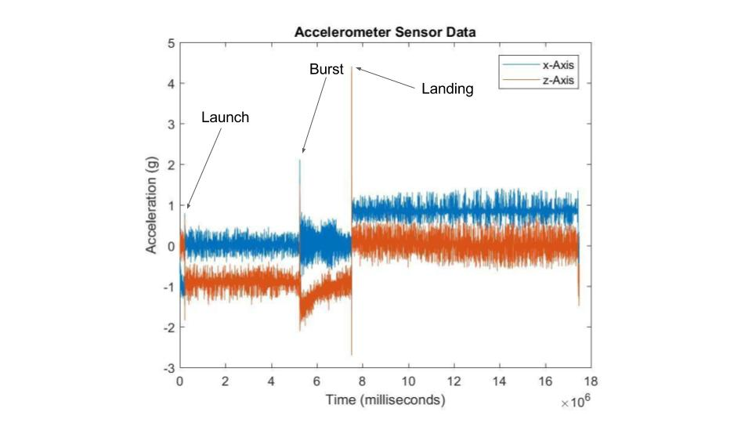

The accelerometer data as seen above also produced results as expected. It can clearly be seen when the balloon launched, when it burst, and when it landed as there are spikes in these instances.

9.2 SkyScrew

*9.2.1 SkyScrew Results*

*SkyScrew Data Overview* shows the flight data generated by the SkyScrew. It began collecting data 3.5 minutes before launch and displays data through landing which was approximately 125 minutes later. *SkyScrew Data (focused)* shows when the SkyScrew was most active. It can be seen that there are voltage spikes to 0.1 volts at 87.89 minutes and again to 0.08 volts at 126.14 minutes. These spikes have been calculated to have occurred approximately at burst and again at landing respectively. Between these two points, intermediate spikes are observed with the majority not exceeding 0.01V.

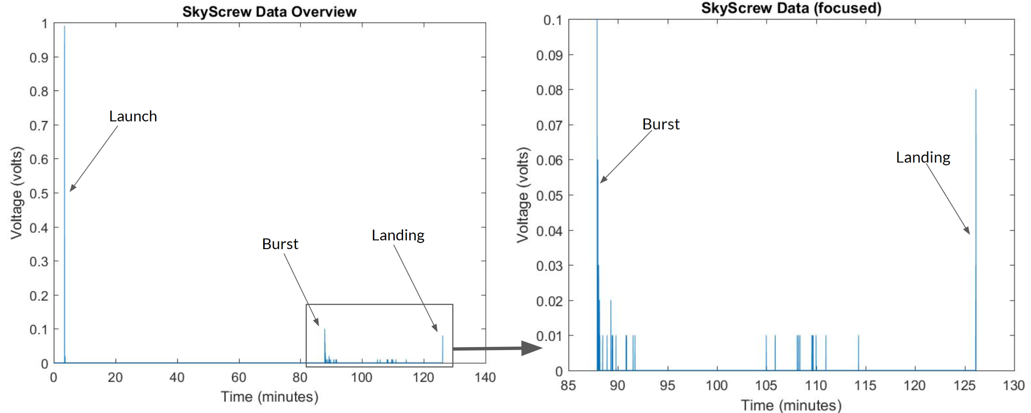

*9.2.2 SkyScrew Data Analysis*

The figure below depicts the expected voltage results from the SkyScrew. It shows the spooling of the SkyScrew as it increases in the rate of rotation. Though the graph is by no means smooth, it shows the general trend of the rotation of the SkyScrew. Team ScrewUp expected to see moments during flight, specifically during ascent in which the data recorded would echo these results. However, as seen in the actual flight data, no data was recorded after launch until burst.



At launch a voltage value of 0.99 volts can be seen. When tested, the average voltage values recorded were between 0.07 to 0.09 volts. This voltage at launch is far from what was expected and are not within the realistic capabilities of the SkyScrew to create. Furthermore, according to the EOSS flight data archives, the balloon rose at an average speed of 13 mph which is faster than the 10 mph wind speed used for testing the SkyScrew. Due to the complete lack of data collected after launch and before burst coupled with the SkyScrew being able to be spun by simply blowing on it the morning of launch indicates a significant event during flight, likely at launch, that prevented the SkyScrew from rotating.

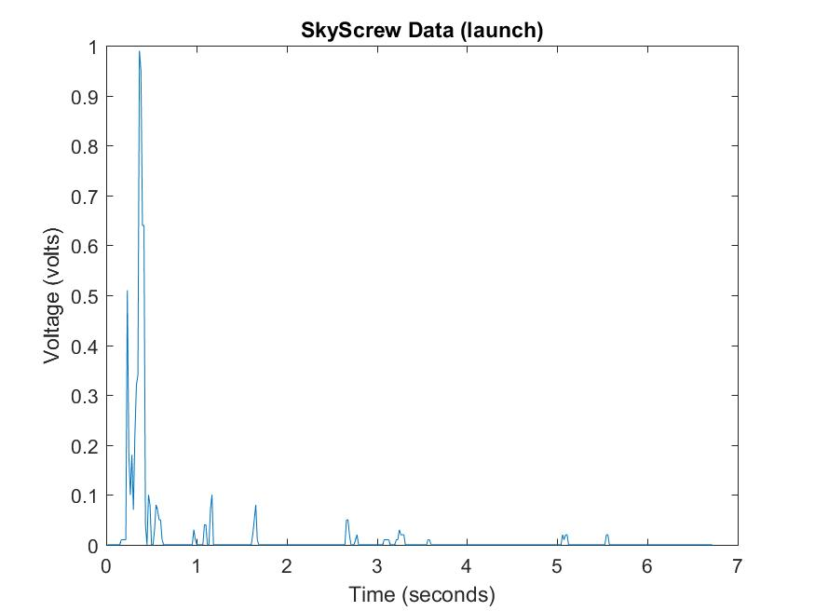

*9.2.3 Skyscrew Failure Analysis*

There are two possibilities that Team ScrewUp explored in an attempt to determine what caused the lack of power to be generated during flight. Because data was read at the most violent parts of flight and an almost max value of 0.99 V at launch Team ScrewUp considered the possibility that there was a fault somewhere in the electrical circuit or Arduino. The other possibility that was investigated was a structural failure at launch where the stress of launch on the SkyScrew’s mechanism damaged it, thus prohibiting it from spinning.

*9.2.3.1 Electrical Investigation*

In the electrical component investigation, Team SkyScrew was not able to find any flaws within the circuit nor the wires used to connect the motor to the Arduino. When tested post-recovery, the circuit was able to function the same way as it had prior to launch, thus allowing Team ScrewUp to rule out a circuit failure.

The next electrical component that Team ScrewUp investigated was that connection to the Arduino itself. Prior to flight, the wires to the Arduino were hot glued in so it seemed unlikely that this was the cause of error. Additionally, to test whether a faulty Arduino connection would lead to failure, Team ScrewUp imitated a faulty connection with the Arduino analog port. When testing this, it was found that rather than reading zeros when there was no connection, the Arduino read random voltage values as seen in the following graph.

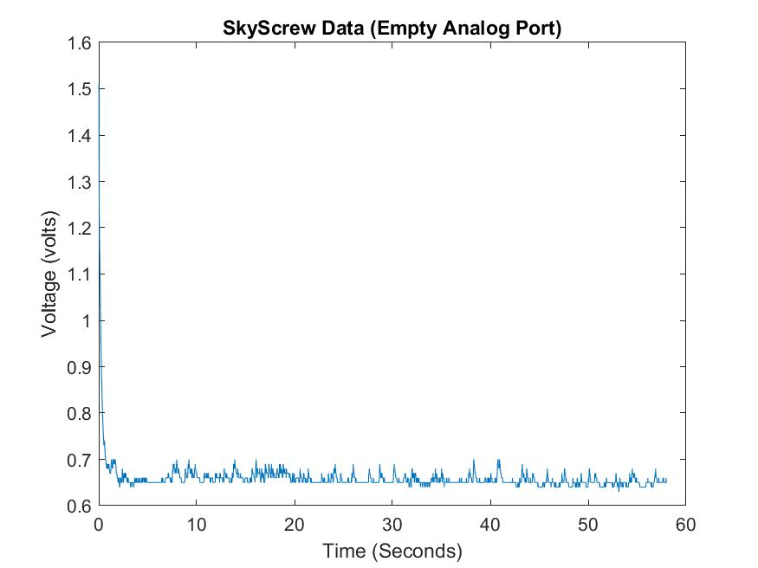

Therefore, Team ScrewUp is able to conclude that the error did not occur due to any kind of electrical failure.

*9.3.2.2 Structural Investigation*

Once electrical failure could be ruled out, the next theory to investigate was the structural failure of the SkyScrew itself. Upon retrieval of the box, the most obvious damaged piece was that the rod was completely broken at the top of the box where the screw was attached. Team ScrewUp was able to to come to the conclusion that this happened at landing because the flightstring at the broken area was not frayed from the sharp edges of the aluminum rod as it would have been if the rod had broken during flight. Team ScrewUp was then able to rule out the completely broken screw as a cause of failure. 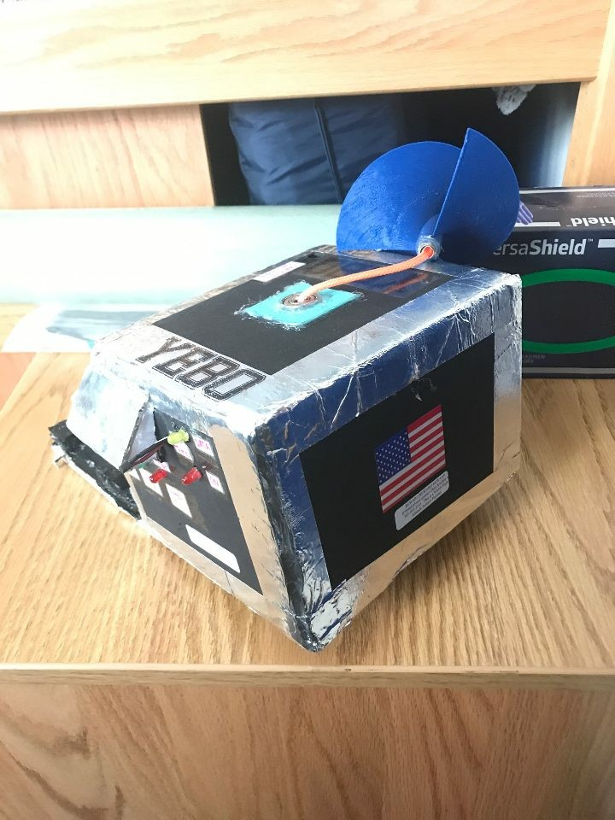

*Broken SkyScrew shaft from retrieval*

After inspecting the physical components of the SkyScrew within the box, it was found that the balls within the bottom bearing were misaligned and broken. Additionally, the shaft was also found to have been bent within the box at the point of connection with the gears and motor, which caused a misalignment between the shaft and the gears, increasing the force necessary to spin the screw. Because the large voltage spike at burst was observed, the moment of launch was Team ScrewUp’s focus of investigation. The team was able to analyze the videos at launch to see if there was any visible concerns from launch. At launch, the screw at the top of the box was pointed in the direction opposite to how the box was pulled when the balloon was released. The force from launch is likely to be the cause of the damaged structural components. This created significant friction, thus preventing the shaft from effectively spinning. This was verified by observation of the rod post-landing and failure analysis testing.

*9.2.4 Skyscrew Failure Replication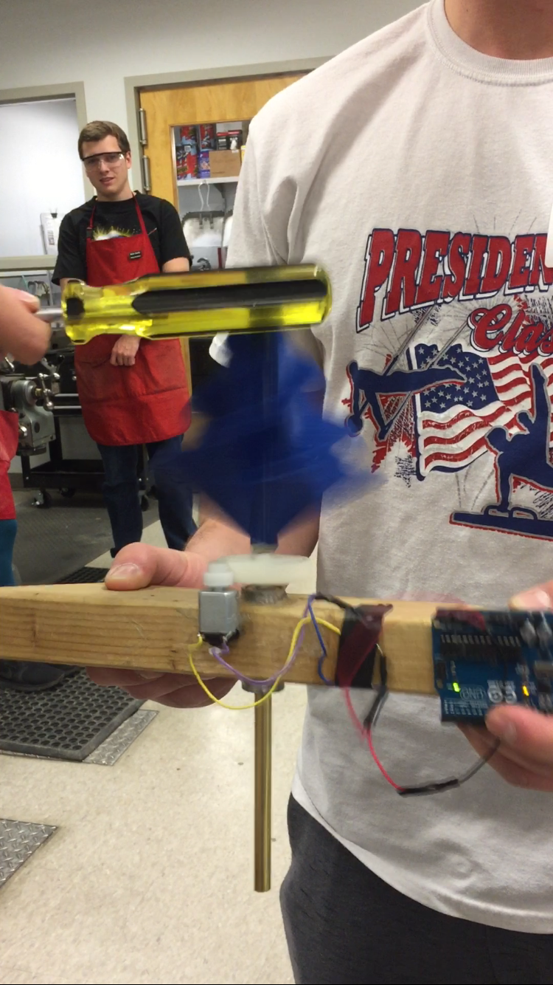*

In order to verify the failure of the SkyScrew, Team ScrewUp rebuilt a test block, previously used during construction, in order to test the failure hypothesis. The goal was to recreate the high data point the Arduino recorded as well as the broken bearings and bent shaft. To accomplish this, the team took the test rig into the ITLL Makerspace to use the high pressure air hose. The hose was used to spin the turbine at a very high rate, to replicate a whipping string on the inside of the tube, the tube was lightly tapped with the handle of a screwdriver while spinning (*Figure 11*). The hypothesis could then be proven correct as the test tube was bent similar to the flight tube as a result of the screwdriver impact. While inspecting the test rig after failure replication, both bearings inside were found to be damaged in the exact way as the bottom bearing used in flight was damaged. Furthermore when the tested shaft and bearings were placed back into the box the SkyScrew was unable to spin under the normal testing conditions.

*Figure 11 - SkyScrew Failure Recreation*

Taking all this into consideration, Team ScrewUp is able to confidently say that the violent launch damaged the structural components of the screw, thus preventing the SkyScrew from rotating and producing power after launch.

9.3 TLCMEG

*9.3.1 TLCMEG Results*

The following figures display the power produced by the TLCMEG during flight. A few very large values make many of the smaller values difficult to distinguish, so the graphs are split to more easily display all the values.

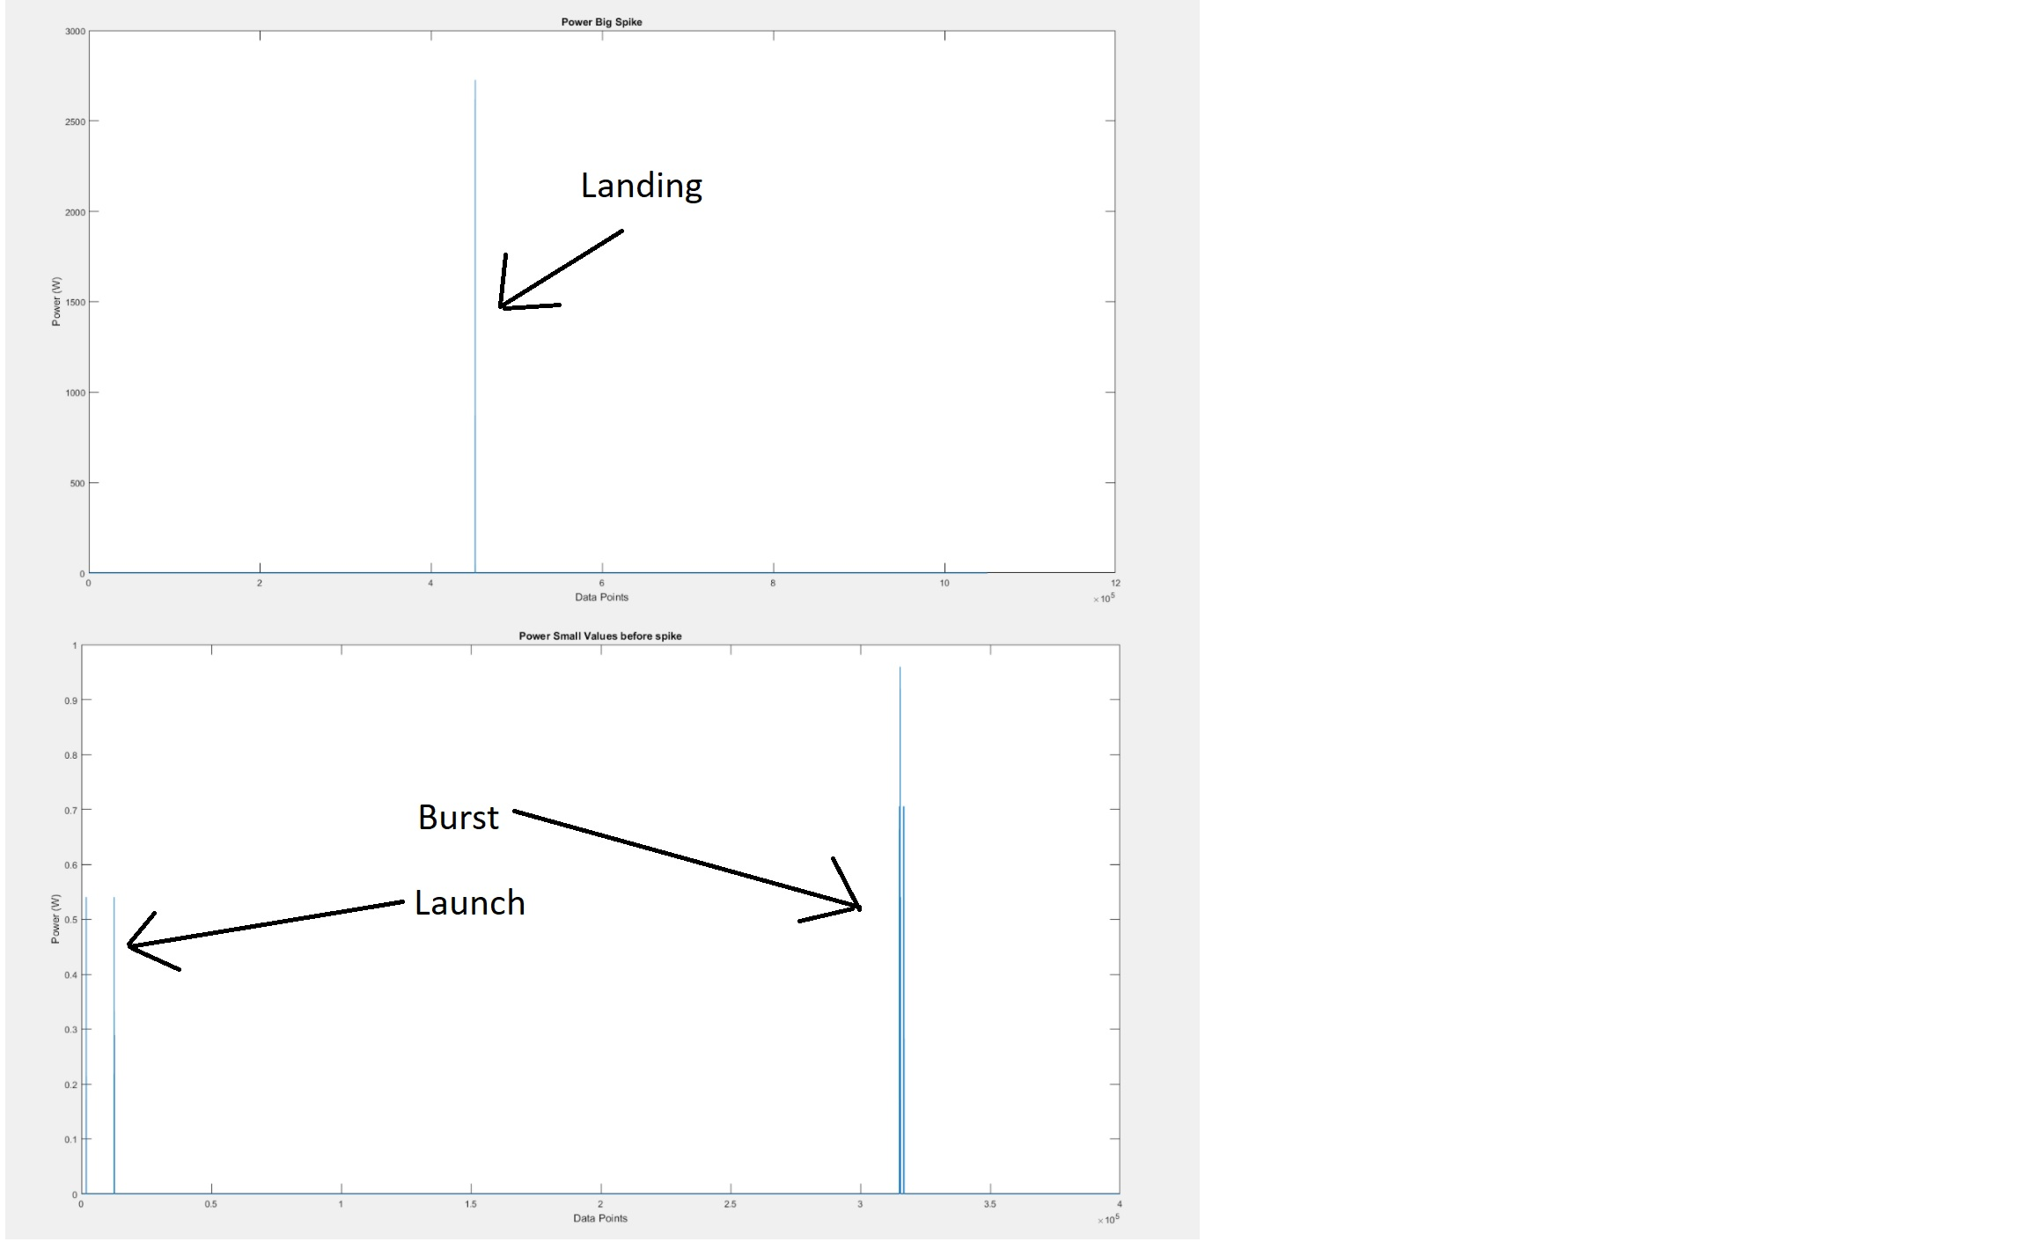

*Figure 12*

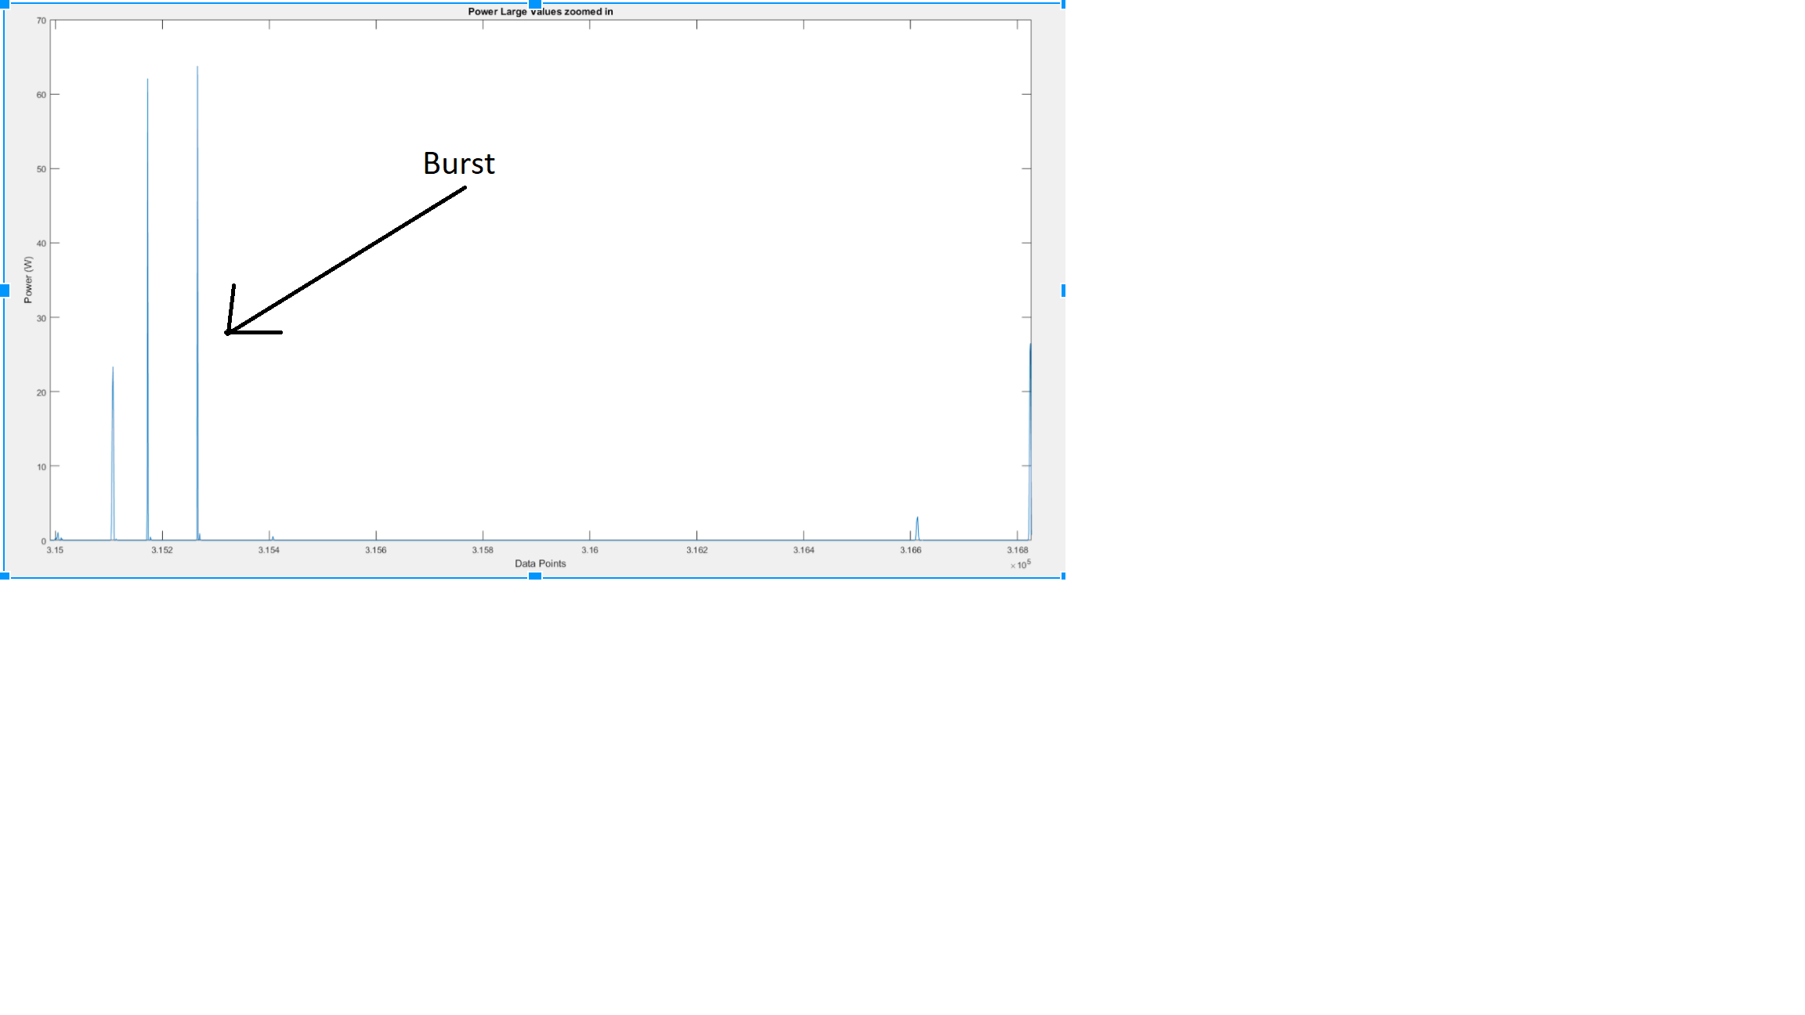

*Figure 13*

Figure 12 represents the total power generated by the TLCMEG during flight. It can be seen that there is only one visible data point, as it is so large that all others are relatively miniscule. *Figures 12* and *13* show a subset of large and small values also collected during flight.

*9.3.2 TLCMEG Data Analysis*

The TLCMEG recorded current and voltage throughout flight. After flight Team ScrewUp realized that the TLCMEG produced voltage values above 5V. The Zener diode prevented this being passed to the Arduino so there were current values without a corresponding voltage value. Before flight, a database was created of voltage and current values in order to correlate them after flight. The database was used to match voltage values from the database to the current values from flight. However, there were current values produced that were not in the database as it was physically impossible for Team ScrewUp to replicate the forces during flight. Therefore, extrapolation was used to calculate the corresponding current and voltage values that were mismatched in order to produce a full set of data. Team ScrewUp were therefore able to calculate the power produced at each data point, which is depicted in *Figure 14*. The TLCMEG data from flight shows that there were several extremely violent motions of the box that generated significant amounts of power at those instances. *Figure 13* zoomed in shows several data points over 50 Watts, and *Figure 12* shows one value of 2726.2935 Watts. This one value is 13,500 times larger than the highest power value Team ScrewUp achieved in testing, showing that the conditions during flight were much more severe than Team ScrewUp could have simulated. Nevertheless, the TLCMEG remained undamaged after such a violent event. This largest value coincides with the time of landing, so it is believed that the high-speed impact caused this largest spike. *Figure 14* represents all positive data points to make visualization easier.

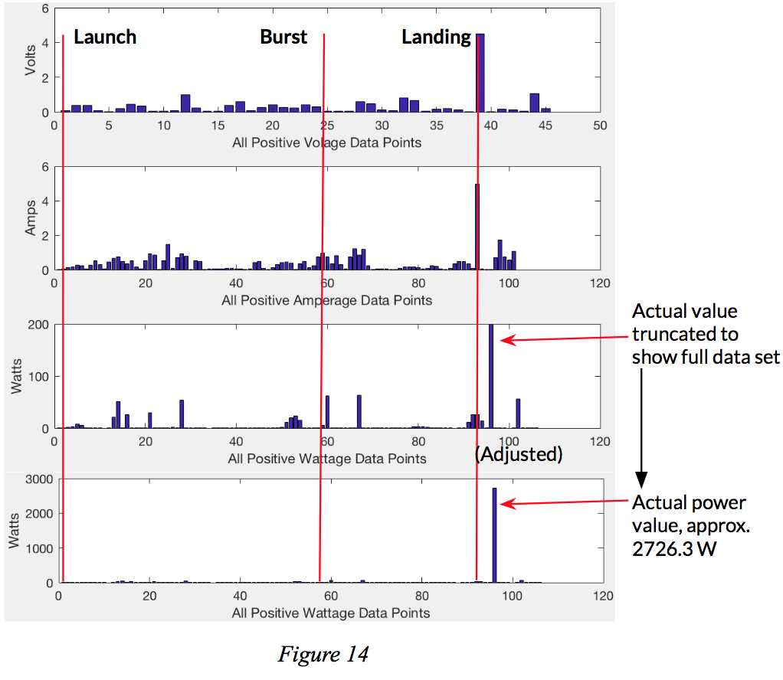

*9.3.3 TLCMEG Failure Analysis*

The TLCMEG only returned 45 voltage values and 101 current values throughout flight, much less than expected considering the amount of motion the box experienced. There were less voltage values due to the zener diode limiting the voltages passed to the Arduino to be below 5V. Upon viewing the onboard camera data, Team ScrewUp saw that the box spun much more than anticipated. Due to this, it is believed that when the box swung side to side, there was a low probability that the TLCMEG was aligned with the direction of the swing. As a result the magnet did not move through the tube during most of the swings, thus not producing data at those instances.

*9.3.4 TLCMEG Failure Replication*

The TLCMEG was suspended from a string and spun. It was then swung side to side, and the magnet rarely slid through the tube because it didn’t hit the walls of the tube very often. This confirmed Team ScrewUp’s hypothesis that the spinning of the box reduced the efficiency of the TLCMEG and led to a lower number of data points than anticipated.

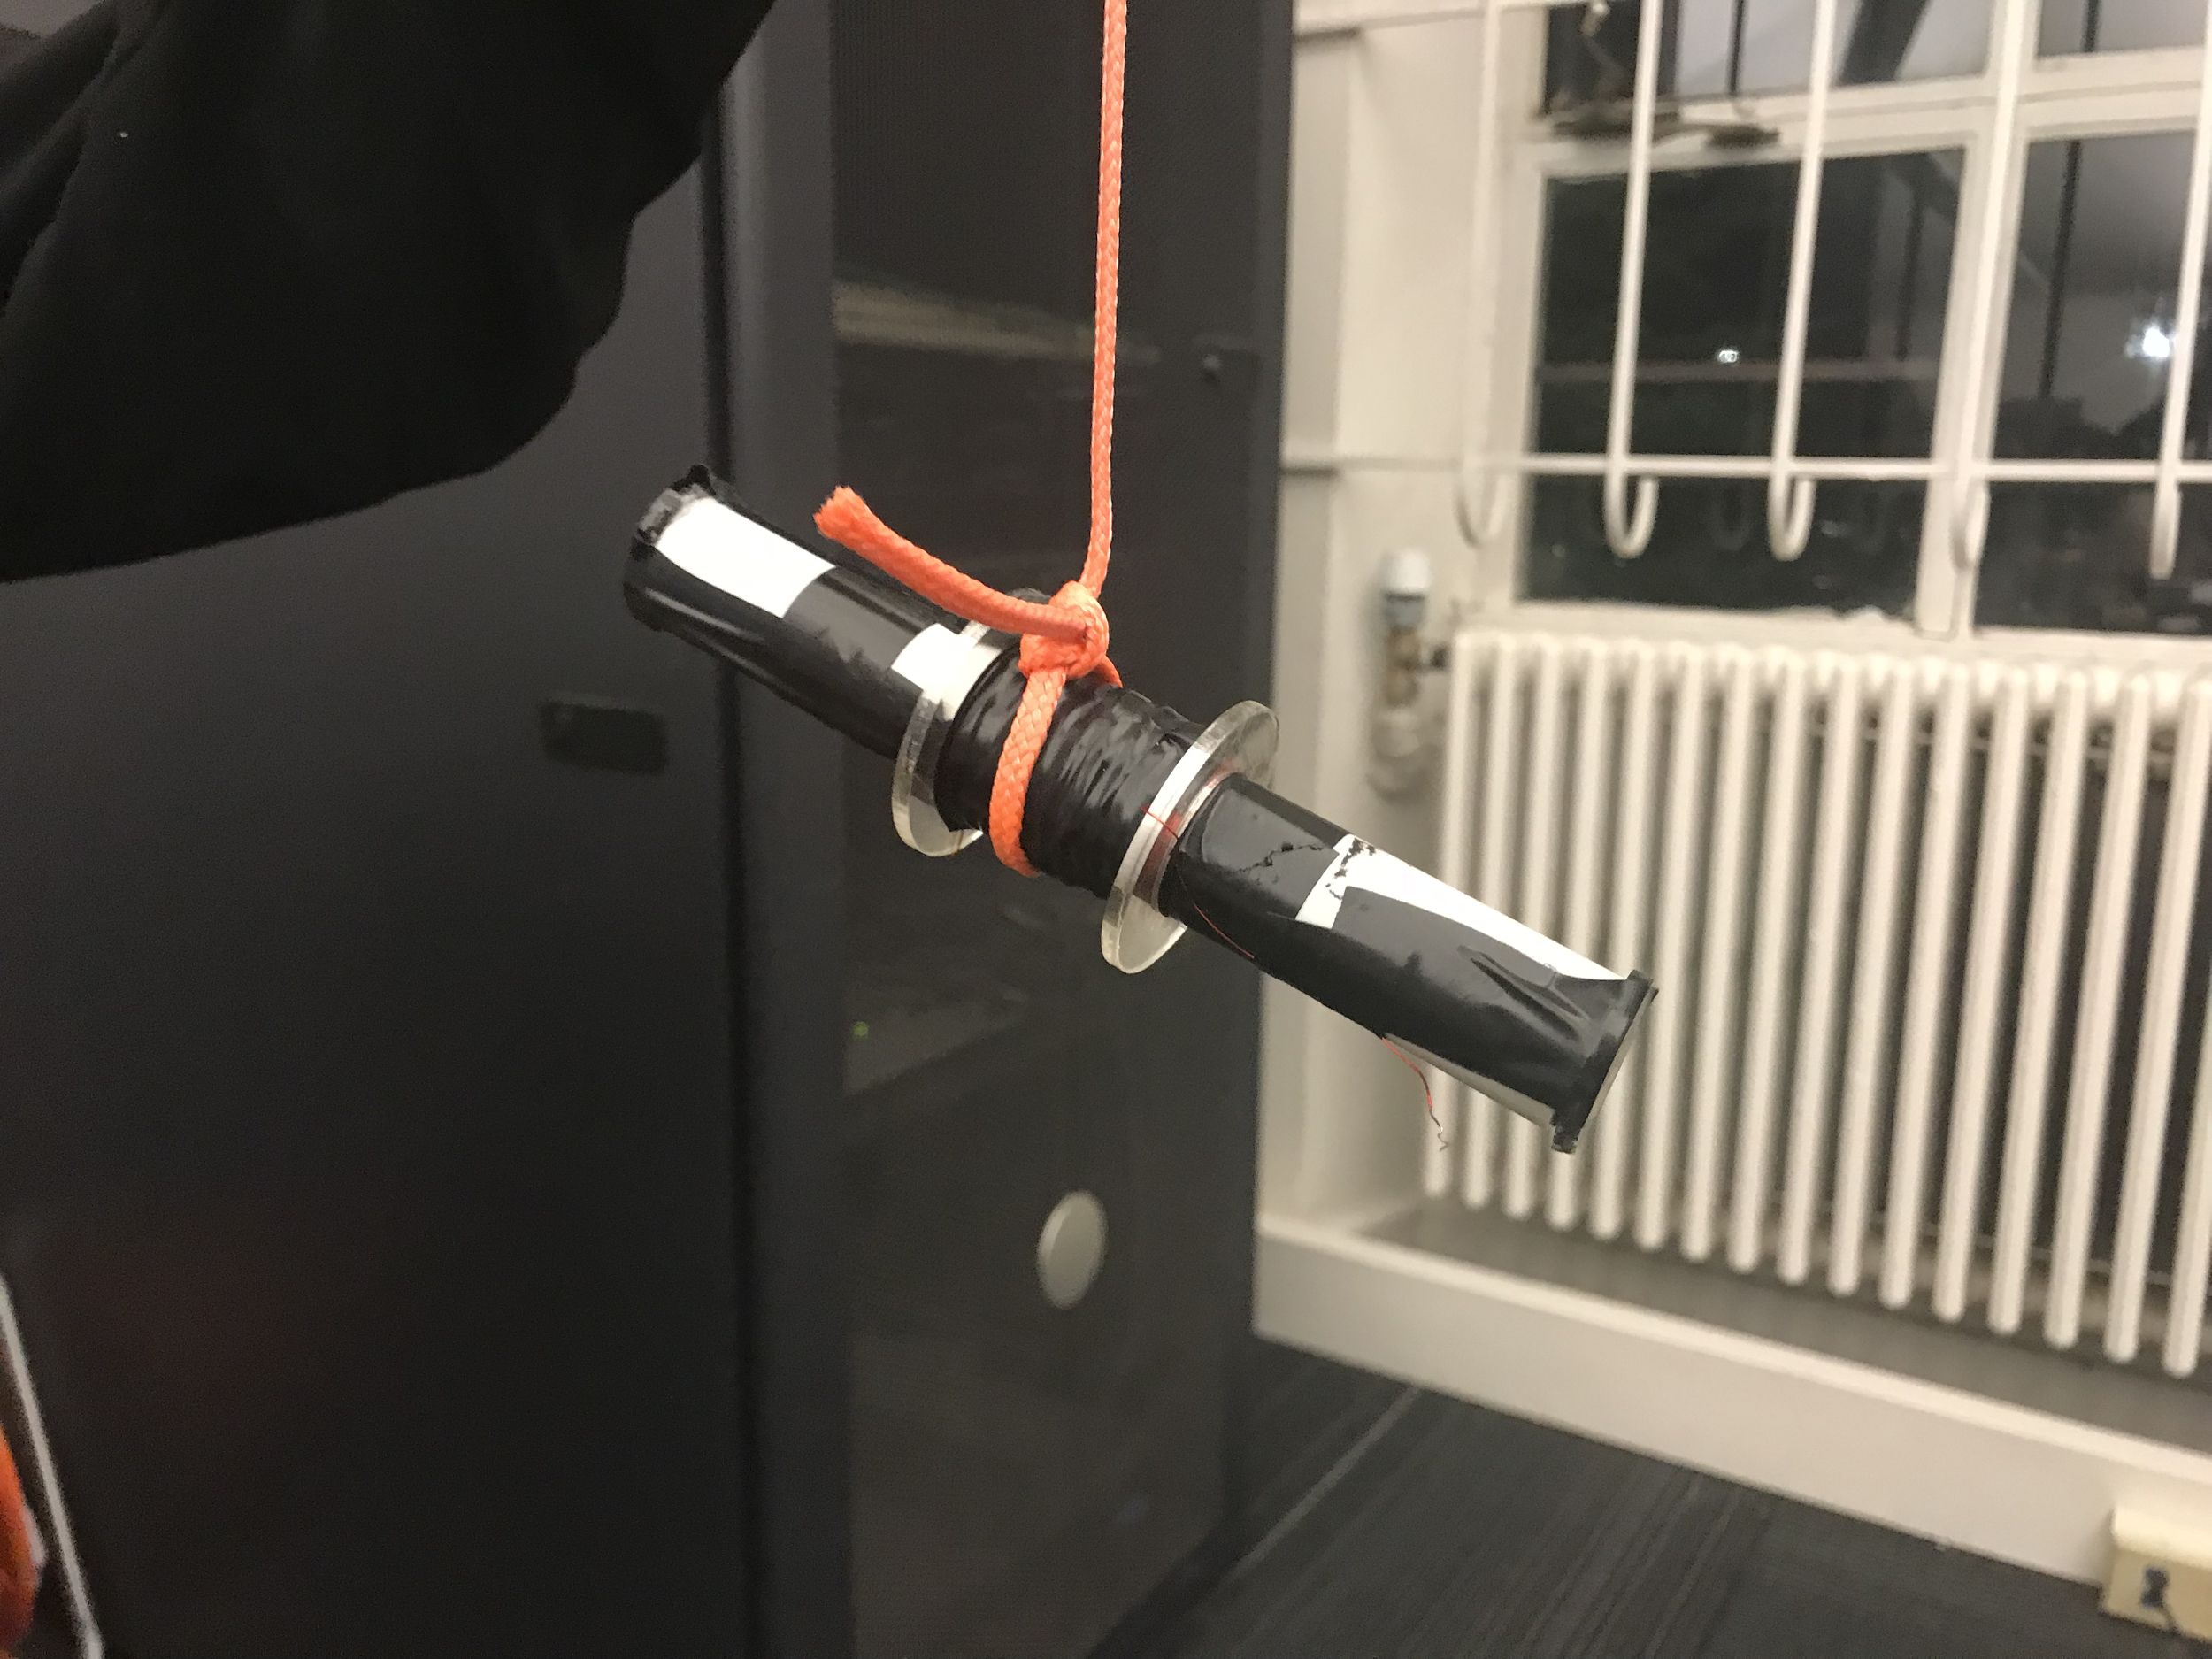

9.4 Conclusion

Team ScrewUp concludes that power was generated. However, due to various design failures that were encountered during flight, the power generated was neither substantial nor consistent. The mission’s goal of generating 500 Watt hours was not accomplished, therefore the mission was a failure due to a flawed design.

The efficiency of Team ScrewUp’s power generation system is unknown due to not proving the theoretical maximum output. Therefore, Team ScrewUp believed that the concept of this mission still has the potential to succeed.

**10.0 Ready for Flight**

To prepare the BalloonSat for flight again and ensure that the same obstacles are not encountered, Team ScrewUp will make multiple changes to the SkyScrew and TLCMEG assemblies. The shaft that runs through the length of the box will be upgraded to a steel tube that has a much higher tensile strength. This will prevent both the bending of the shaft upon launch as well as the likelihood that the shaft may break upon landing. In addition to the upgraded shaft, the bearings will also need to be replaced with high strength steel bearings to prevent damage occurring from whipping. Team ScrewUp will also apply fins to two sides of the BalloonSat opposite of each other, so that the box can spin in the opposite direction of the SkyScrew to generate more power. Along with this, a second TLCMEG could be constructed perpendicular to the first, in order to generate power on more swings of the box. Currently all broken components have been replaced and new batteries placed in the box. Additionally, the SD cards are cleared and the GoPro battery has been charged. Team ScrewUp’s BalloonSat should be stored with no pressure or objects pressing against the SkyScrew and due to the powerful Neodymium magnet in the TLCMEG, it is not advised to put any data storage devices near the BalloonSat. To activate the payload simply flip on all the switches; they can be turned on in any order. Other than the batteries, which will slowly lose charge over time, there are no time sensitive pieces of equipment and the BalloonSat could be stored indefinitely.

**11.0 Lessons Learned**

Team ScrewUp learned many things throughout this semester. One of the most important things learned was the value of testing. If given the chance to redo this flight, Team ScrewUp would perform even more tests than were performed the first time around. In making a completely new assembly there are a multitude of different aspects that could be analyzed and contemplated to produce the optimal results. Communication is key. Keeping good communication skills throughout the duration of the project is essential especially when the project is approaching its terminus. The team tends to becoming fatigued towards the end of the semester, and it is important to power through. It was often helpful to write on the whiteboard all of what was going on, what needed to happen, and then the details of what to do. Also, Team ScrewUp learned not to skimp out on bearings.

**12.0 Message to Next Semester**

Start working on your project as soon and as consistently as possible. Don’t be afraid to choose something unique and ambitious as it is a lot more fun to do something you will become invested in. While 4 months may seem like a large chunk of time, it really isn’t. The sooner you get started, the better off you’ll be. Create a schedule that enables you to finish your project two weeks before launch. Those two weeks are a buffer for all of the unforeseen circumstances that will inevitably happen. After you’ve set a schedule for your project, create another schedule with your group for when you’ll be meeting and stick to that schedule as best as possible. When making this schedule, keep in mind that it’s much better to meet too often than not often enough. Having a set schedule not only holds group members accountable, but also facilitates consistent progress. Once the schedule has been set, make sure you establish some form of group communication. GroupMe and Slack are two of the most common and easy to use apps for group chats.

There will be times during this project where you come across problems you don’t know how to solve and that’s okay. There are plenty of resources that you can go to in the engineering center. Some of the best sources available to you are the staff in the ITLL. They have many years of experience and have all worked on projects similar to yours. When exams come around, make sure to give yourselves plenty of time to study. Taking a break from working on your project is necessary. It gives you time for your other classes but it's also a good mental break from your project. There will be times when it feels like nothing's going your way and that you won’t finish on time, but if you continue to work hard and consistently, you’ll find that it was all worth it in the end.

1. “Gateway to Space” : ASEN 1400 Course

   http://spacegrant.colorado.edu/boulderstudents/gateway-to-space-home
2. “Greening CU” : The University of Colorado Boulder,

   https://www.colorado.edu/ecenter/greening-cu
3. “Pioneer Profile.” Leonardo da Vinci : The American Institute of Aeronautics and Astronautics, www.aiaa.org/secondarytwocolumn.aspx?id=15129. Accessed 15 Oct. 2017.
4. “Advantages and Challenges of Wind Energy.” Advantages and Challenges of Wind Energy, U.S Department of Energy, energy.gov/eere/wind/advantages-and-challenges-windenergy. Accessed 20 Sept. 2017.